RC Baja Buggy
Drivetrain & Chassis

By

Sam Wang
Team member: Skyler Gordon

ABSTRACT

The RC Baja project aims to develop a high-performance RC vehicle for Baja-style racing through a comprehensive design, manufacturing/prototyping, and testing. The objective is to address engineering challenges related to ensuring durability, efficiency, and performance while navigating rugged terrains and obstacles.
To achieve this objective, the engineers conduct extensive research to guide the design process, with a specific emphasis on the drivetrain and chassis components. Detailed CAD modeling is utilized to refine the design of the drivetrain, incorporating elements such as gear ratios, differential systems, and torque distribution to enhance power delivery and traction. Similarly, the chassis design prioritizes factors such as weight distribution, ground clearance, and structural integrity to withstand the stresses encountered during aggressive off-road driving.
The implementation of engineering principles yields promising results in both the drivetrain and chassis components. Testing reveals the function of the vehicle to meet expectations and requirements which allow the engineers to compete in the ASME Baja competition. The drivetrain design demonstrates improved efficiency, maximizing power transfer to the wheels and minimizing energy losses. This resulted in a top speed of 30 mph. Similarly, the chassis design enhancement results in increased durability and responsiveness, allowing the vehicle to withstand impacts and rough terrain while maintaining agility and control. This resulted in a deflection of less than 1/8 of an inch. Overall, the project’s focus on refining the drivetrain and chassis components which contributes to the development of a high-performance RC Baja vehicle capable of excelling in competitive off-road racing scenarios.

__________________________________________________________

Keywords: RC, Engineering, Design, Gear Ratios, Research, Chassis, Drivetrain.

Contents
ABSTRACT 2
1. INTRODUCTION 8
a. Description 8
b. Motivation 8
c. Function Statement 8
d. Requirements 8
e. Engineering Merit 9
f. Scope of Effort 9
g. Success Criteria 9
h. Stakeholders 9
2. DESIGN & ANALYSIS 10
a. Approach: Proposed Solution 10
b. Design Description 10
c. Benchmark 10
d. Performance Predictions 10
e. Description of Analysis 11
f. Scope of Testing and Evaluation 11
g. Analysis 11
i. Analysis 1 – Maximum Motor Power 11
ii. Analysis 2 – Maximum speed 11
iii. Analysis 3 – Chassis Deflection 11
iv. Analysis 4 – Diameter of Gear Shaft 11
v. Analysis 5 – Bolt Shear Force 12
vi. Analysis 6 – Diameter of Drive Shaft 12
vii. Analysis 7 – Torque Tube Size by Shears 12
viii. Analysis 8 – Acceleration 12
ix. Analysis 9 – Friction Heat from Bearing 12
x. Analysis 10 – Bumper Deformation 12
xi. Analysis 11 – Battery Life 12
xii. Analysis 12 – Gear Ratio and Motor Torque 13
h. Device: Parts, Shapes, and Conformation 13
i. Device Assembly 13
j. Technical Risk Analysis 13
k. Failure Mode Analysis 13
l. Operation Limits and Safety 14
3. METHODS & CONSTRUCTION 15
a. Methods 15
i. Process Decisions 15
b. Construction 16
i. Description 16
ii. Drawing Tree, Drawing ID’s 16
iii. Parts 16
iv. Manufacturing Issues 17
v. Discussion of Assembly 17
4. TESTING 18
a. Introduction 18
b. Method/Approach 18
c. Test Process 18
d. Deliverables 18
5. BUDGET 19
a. Parts 19
b. Outsourcing 19
c. Labor 19
d. Estimated Total Project Cost 19
e. Funding Source 19
f. Winter Updates 19
g. Spring Updates 20
6. SCHEDULE 21
a. Design 21
b. Construction 21
c. Testing 21
7. PROJECT MANAGEMENT 22
a. Human Resources 22
b. Physical Resources 22
c. Soft Resources 23
d. Financial Resources 23
8. DISCUSSION 24
a. Design 24
b. Construction 24
c. Testing 25
9. CONCLUSION 26
a. Design 26
b. Construction 26
c. Testing 26
10. ACKNOWLEDGEMENTS 28
References 29
APPENDIX A - Analysis 30
Appendix A01 – Maximum Motor Power 30
Appendix A02 – Maximum Speed 31
Appendix A03 – Chassis Deflection 33
Appendix A04 – Diameter of Gear Shaft 34
Appendix A05 – Bolt Shear Force 35
Appendix A06 – Diameter of Drive Shaft 36
Appendix A07 – Torque Tube Size by Shear 37
Appendix A08 – Acceleration 38
Appendix A09 – Frictional Heat from Bearing 39
Appendix A10 – Bumper Deformation 40
Appendix A11 – Battery Life 41
Appendix A12 – Gear Ratio and Motor Torque 42
APPENDIX B - Drawings 43
Appendix B01 – Drawing Tree 43
Appendix B02 – Drawing Index 44
Appendix B03 – SMW-10-101 – Full Vehicle Assembly 45
Appendix B04 – SMW-10-102 – Spur Housing Sub-Assembly 46
Appendix B05 – SMW-10-103 – Drive Train Assembly 47
Appendix B06 – SMW-20-101 - Motor Mount 48
Appendix B07 – SMW-20-102 – Chassis (Rear) 49
Appendix B08 – SMW-20-103 – Chassis (Front) 50
Appendix B09 – SMW-20-104 – Chassis Connecting Bar 51
Appendix B10 – SMW-20-105 – Spur Gear Mount 52
Appendix B11 – SMW-20-106 – Spur Attachment 53
Appendix B12 – SMW-20-107 – ESC Housing 54
Appendix B13 – SMW-20-108 – Cable Arch 55
Appendix B14 – SMW-20-109 – Drive Shaft Connection 56
Appendix B15 – SMW-20-110 – Differential Housing (Bottom) 57
Appendix B16 – SMW-20-111 – Differential Housing (Top) 58
Appendix B17 – SMW-20-112 – Spur to Shaft Connection 59
Appendix B18 – SMW-20-113 – Shaft to Diff Connection 60
APPENDIX C – Parts List and Costs 61
Table C1 – Purchased Parts List 61
Table C2 – Fasteners 62
APPENDIX D – Budget 63
Table D1 – Project Budget 63
APPENDIX E – Schedule 64
Gantt Chart: Fall Quarter 64
APPENDIX E – Schedule Cont. 65
Gantt Chart: Winter Quarter 65
Gantt Chart: Spring Quarter 65
Appendix F – Expertise and Resources 66
Appendix F01 – Chassis Style Matrix 66
Appendix F02 – Chassis Material Matrix 67
Appendix F03 – Chassis Manufacturing Matrix 68
Appendix F04 – Axle Connecting Shaft Matrix 69
APPENDIX G – Testing Report 70
Appendix G1 (Top Speed) 70
Introduction 70
Method/Approach 70
Test Procedure 70
Deliverables 72
Appendix G1.1 – Procedure Checklist 72
Appendix G1.2 – Data Forms 72
Appendix G1.3 – Raw Data 72
Appendix G1.4 – Evaluation Sheet 72
Appendix G1.5 – Schedule (Testing) 72
Appendix G2 (Acceleration from Stop) 73
Introduction 73
Method/Approach 73
Test Procedure 73
Deliverables 73
Appendix G2.1 – Procedure Checklist 73
Appendix G2.2 – Data Forms 73
Appendix G2.3 – Raw Data 73
Appendix G2.4 – Evaluation Sheet 73
Appendix G2.5 – Schedule (Testing) 73
Appendix G3 (Chassis Deflection) 74
Introduction 74
Method/Approach 74
Test Procedure 74
Deliverables 74
Appendix G3.1 – Procedure Checklist 74
Appendix G3.2 – Data Forms 74
Appendix G3.3 – Raw Data 74
Appendix G3.4 – Evaluation Sheet 74
Appendix G3.5 – Schedule (Testing) 74
Appendix H – Resume 75

1. INTRODUCTION

a. Description
The Central Washington University (MET) RC Baja buggy was a customed design remote controlled vehicle that involves engineering and analysis to produce a functioning vehicle that did operate through rough terrain and complete courses. The team was solving the engineering problem by creating a 1/10th scale of an RC Baja buggy that utilizes a drivetrain, steering, suspension, and chassis. The team were also solving engineering problems relating to the chassis and drivetrain. The chassis did take hard impact and maintain structure and the drivetrain was adjustable to tune the vehicle for speed and crawling. The RC vehicle did resemble a full-size Baja buggy. When completed, the RC Baja buggy did compete against the other teams to race.

b. Motivation
The team was motivated by the need to successfully design and construct a working RC Baja buggy with minimal to no issues when operating. Determined to crush the opposing teams competing in the competition. The learning experience for the teammates was crucial for mechanical design and development. This experience directly transfers to real-world experience involving complex design, teamwork, and management skills.

c. Function Statement
The drivetrain creates torque to the wheels. The chassis provides structure and mounting points for the components.

d. Requirements
The requirements listed were the standard ASME criteria for the competition in order to race in the final. The design of the Baja buggy car was meet all the requirements and more, successfully passing the criteria listed.
- One propulsion motor with a power output of 250 watt which drives the whole vehicle. One 5200mAh battery per vehicle that lasts longer than 20 mins.
- Being able to operate the vehicle within a range of 20 meters.
- The drivetrain on the vehicle will be sustainable at a speed of 25 miles per hour.
- The bumper attached to the vehicle must take a frontal impact of 15lb with minimal damage.
- The plastic body ornament for the RC Baja buggy will use 4 mounting points to be attached.
- The driveshaft will contain a slip joint in the center, and it will extend at least 15mm in both directions, for a total of 30mm of travel.
- The overall length of the vehicle will be less than 20 inches and overall width will be less than 12 inches.
- Adjustable motor mount with a 1/4 inches of play for adjustment.
- The electric motor with a power output of 1850 watts.
- Off-roading tires with appropriate tread patterns for rough terrain, should be 1/8 scale wheels.
- 3D Printed PLA+ chassis frame weighing 2.5 lb.
- Chassis deflection no more than half of inch with 20lbs.
- Bumper deflection no more than half of inch.
- Gear prop shaft must withstand 5lb of torque.
- Flexure in axel strength are 60MPas
- Have at least 5:1 Gear ratio.
- Heat produced by the bearing does not exceed the temp of 35 degree Celsius.
- Vehicle must survive 2 feet on the drop test.
- Accelerate to 20 mph in less than 10 seconds.

e. Engineering Merit
In order for this project to be completed, many different engineering approach was required, like mechanics of materials and statics. The calculations for the different components will be done on engineering green sheet paper to analyze the forces applied within the vehicle. Using the mechanics of materials for strength to analyze the designs and assemblies for the RC Baja buggy. Using SolidWorks/fusion 360, machining, and proprietary parts to create the creation of the Baja buggy. Learning new skills like project management and time constraints was crucial for new engineers.

f. Scope of Effort
The process of producing this RC vehicle was divided between drivetrain & chassis, and suspension & steering. Sam was assigned the drivetrain & chassis while Skylar was assigned suspension & steering. The scope of effort will be focused on the drivetrain & chassis component of the RC Baja buggy as well as how these components will be mounted on the chassis. The drivetrain will include the power delivery to the transmission, driveshaft, and gear. The chassis will be a sturdy structure to provide adequate mounting for all the required components. Collaboration within the team was crucial in order to complete the RC Baja buggy project.

g. Success Criteria
The success of this project vehicle will be determined by the competition hosted by the ASME club. The Baja buggy will satisfy the ASME Baja buggy requirement in the rule book. There were three challenges in the course the vehicle will be going through. Team members will self-evaluate on how well the design and application of their part perform. The team will reflect on the end result of the vehicle’s performance and learn the pros and cons and improvements of the project.

h. Stakeholders
The stakeholders of this RC Baja buggy project will include the team members creating the vehicle. Sam and Skylar will directly benefit from the completion of this project. The stakeholders will also be the professors associated with the project. Professor Pringle, Dr Choi, and other supportive professors who have invested in the education of Sam and Skylar.

2. DESIGN & ANALYSIS

a. Approach: Proposed Solution
The primary objective of the RC Baja buggy project was to conceive, design, and fabricate a fully functional RC car capable of competing effectively against other RC Baja vehicles in the ASME competition. The core focus was on meeting the functional requirements outlined in the project's introduction. Significantly, the drivetrain and chassis were engineered to deliver ample power and robust support, ensuring seamless operation without encountering any notable issues. This optimization aimed to strike a balance between performance, durability, and reliability, with the ultimate goal of excelling in the demanding ASME competition environment.

b. Design Description
The current design of the Baja buggy involved a 3d-printed flat frame chassis that has multiple printed orientation to ensure maximum strength of the print. The power from the motor did transfer to the driveshaft into the differential with a 3:1 ratio.

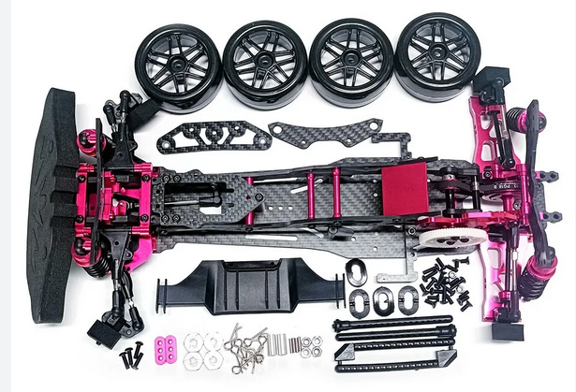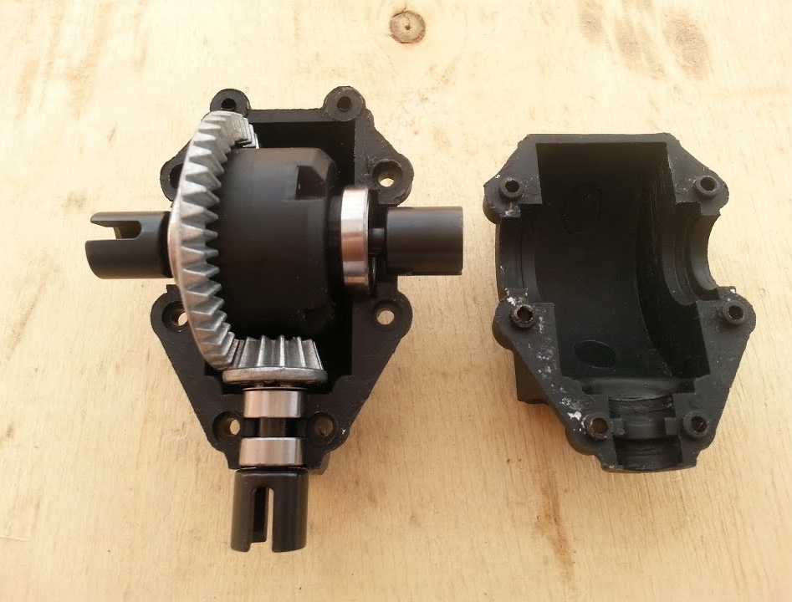
Image 2.1 Image 2.2

c. Benchmark
The benchmark for this Baja buggy was compared to the Holyton 1:10 highspeed remote control car with a max speed of 48km/h from Amazon. This benchmark vehicle closely resembled the project design with the same ability to navigate through rough terrain. The components were roughly in location in the respected benchmark vehicle to provide a resemblance of a car.

d. Performance Predictions
The performance prediction for the drivetrain was to supply adequate power for the RC Baja buggy to reach the speed of 20 mph in less than 10 seconds. It performed like the commercially bought RC cars from reputable companies. The quality of the component was different than standard off-the-shelf parts available from websites, but it functioned exceptionally well, meeting the project’s performance goal.

e. Description of Analysis
The analysis for the components was calculated based on the maximum capability to ensure it meets the requirement and more. Free body diagram, along with statics and dynamics were applied to calculate the forces exerted on both chassis and drivetrain, confirming they delivered the necessary power and support. The application of mechanics of material was applied to decide if the material and design of the component was used to determine if the component was robust enough to withstand operational stresses and prevent any possibility of failure.

f. Scope of Testing and Evaluation
The RC Baja buggy was tested to evaluate the necessary criteria to meet the requirements outlined in section 1d. Testing the RC car by putting it through rough handling, impact situations, and intricate maneuvering to ensure it completes the requirements. These tests were confirming that the vehicle not only met but surpassed the requirements, ensuring resilience and performance.

g. Analysis

Analysis 1 – Maximum Motor Power
This analysis was conducted to determine the maximum motor power for the TrackStar 1/10th 80A Turbo brushless Motors. This was necessary in order to calculate analysis for power to the wheels for acceleration and speed. In Appendix A01, the maximum motor power was calculated to be 239.76W. On the official website for the motor, it was indicated the maximum watt was 255W. The slightly lower calculated value was a result of factoring in motor efficiency, ensuring a more precise estimation of real-world performance.

Analysis 2 – Maximum speed
This analysis was conducted to determine the maximum speed capability for the TrackStar 1/10th 80A turbo brushless motor with a 4-inch diameter wheel. The maximum speed needs to be at least 20 mph at half power as stated in section 1d. In Appendix A02, the maximum speed determined was to be 63.73 mph which exceeds more than 3 times the requirement at full power.

Analysis 3 – Chassis Deflection
This analysis was conducted to determine the deflection of the chassis. This was necessary in order to determine the amount of deflection the chassis would endure. In Appendix A03, the maximum deflection calculated was 0.154 in. The deflection was not an issue for the RC Baja Buggy components to perform at their best.

Analysis 4 – Diameter of Gear Shaft
This Analysis was conducted to determine the diameter of the gear shaft needed for the RC Baja Buggy. This was necessary to determine the adequate amount needed to endure the torque acted on it. The shaft will be bigger than it needs, the more the better. The selected shaft diameter was 1/4 inch.

Analysis 5 – Bolt Shear Force
This analysis was conducted to determine the shear force required to break the M5 bolt used for the housing component on the RC car. This was necessary because of the amount of torque and force acted upon the housing, knowing the maximum force the bolt is capable of holding will ensure an adequate mounting for the motor housing component. In Appendix A05, it shows the M5 bolt was capable of withstanding 471.24LB of force.

Analysis 6 – Diameter of Drive Shaft
This analysis was conducted to determine the diameter of the drive shaft required with a 3 N-m of torque and 5 degrees of deflection. The length was 100mm using A36 steel. This was necessary because the diameter of the drive shaft must be more than sufficient to withstand the 3 N-m of torque. In Appendix A06, it shows the minimum diameter is 0.18 inch. So, the quarter-inch diameter shaft will be sufficient.

Analysis 7 – Torque Tube Size by Shears
This analysis was conducted to determine the diameter size of the shaft with torque acted upon it. This analysis is for the shaft that drive from the spur gear to the differential. In appendix A07, the calculation came out with 6.188mm in diameter which equivalent to 0.25 inches. The 0.25 inches shaft will be sufficient for the torque.

Analysis 8 – Acceleration
This analysis was conducted to determine the acceleration of the motor to the wheels if neglecting friction. Based on the max speed the motor output from Appendix A02 with the requirement in 1d3 and 1d19. The calculation came out of 7.334 ft/s^2 for the acceleration if neglecting friction. This is calculated with a 5s timeframe.

Analysis 9 – Friction Heat from Bearing
This analysis was conducted to determine the friction heat produced by the 608-2RS bearing to see if it is sustainable in a PLA+ housing. The heat transfer calculation shows it created 532.88 joules of energy which is converted to Celsius which is a 0.281-degree increase as shown in Appendix A09. The time set was 10 minutes of run time which is more than its needs to complete the ASME Baja course.

Analysis 10 – Bumper Deformation
This analysis was conducted to determine the deflection on the bumper under load and impact at 25 mph. This calculation was important because the RC car will frequently experience crashes which were mainly directly on the bumper. The bumper experienced 0.42 inches of deflection under 20lb of load and the impact at full speed of 25 mph deflected at 3.589x10^-4.

Analysis 11 – Battery Life
This analysis was conducted to determine the battery life of the Zeee 5200 mAh battery. This calculation was necessary because the battery life must be able to endure the time duration of the ASME Baja course. In Appendix A11, it was calculated that the battery will last 1.04 hours in direct current load. This duration will be longer because the operation will be on and off during the whole event. The amount calculated was more than sufficient to satisfy the requirement listed in 1d.1 which only requires running for 20 minutes straight. This battery will be the primary source in the competition.

Analysis 12 – Gear Ratio and Motor Torque
This analysis was conducted to determine the correct gear ration required to run the 3040kv motor with the 7.4v battery to reach the sustainable speed of 30mph as pointed out in 1d.3. In appendix A12 the train value calculated to reach that was 11.154. In order to reach that with the given pinion teeth of 18, the spur gear must have 200 teeth which was too large for the vehicle. Two gear set was determined to be used to reach the desired TV. New ratio came out to be 8.2 with an 86T to 21T spur/pinion set and 30T to 15T bevel gear set at the rear.

h. Device: Parts, Shapes, and Conformation
The design for the drivetrain and chassis was based on an analysis of materials to select which material and what dimensions were the most suitable options to go with. The initial designs were blocky and generic but as time and design went on, the blocky shape started to take shape of the final design. The chassis had an appropriate amount of real estate to mount every component and provide a strong structure to take impacts. Less is more.

i. Device Assembly
The assembly process of the RC Baja buggy closely resembled that of commercially available vehicles. Common parts were thoughtfully designed for easy replacement, ensuring accessibility without the need for excessive disassembly. The flat chassis design proved particularly advantageous, as it provided clear visibility and easy access to all attached components. This approach enhanced both maintenance and user-friendliness.

j. Technical Risk Analysis
The primary goal of this project was to place a strong emphasis on maneuverability control and power delivery, all while maintaining an optimal balance between speed and vehicle weight. The lighter the vehicle, the more power it has. Using strong lightweight material and a simple design ensures the awareness of weight which plays a direct role in power and control. Utilizing high-performance parts increases the success of the vehicle.

k. Failure Mode Analysis
The RC Baja buggy typically faces its most common failures during operation, mainly from the rough impacts it encounters, and component fatigue caused by torque. Among these components, the differential bears the brunt of fatigue, primarily due to the forces generated during acceleration and torque application. Additionally, the impacts on the bumper and chassis, resulting from jumps, landings, and occasional operator errors, contribute significantly to wear and tear.

l. Operation Limits and Safety
The project's safety risk assessment primarily focuses on electrical and mechanical hazards. When it comes to electrical concerns, the assembly process involving electronics and batteries carries the potential risk of electric shock or even fire if not handled properly. On the mechanical front, particular attention is given to components that articulate, as they can pose pinch-point hazards and may be susceptible to part failure during testing.

3. METHODS & CONSTRUCTION

a. Methods
The manufacturing process for the RC Baja Buggy was done using the 3D Printer (Creality Ender 3 S1) and machining (Lathe and Bridgeport). The main method of manufacturing was 3D printing due to the rapid prototyping and ease of accessibility. Within the constraints of the university resources, parts will be manufactured using a combination of in-house production and outsourcing for specialized components. Collaboration with external manufacturers will be sought for specific, high-precision parts that require advanced techniques or materials not readily available in-house. This approach combines the advantages of the university's resources with the specialized capabilities of external partners to ensure efficient and precise manufacturing of the solution. The risk of utilizing external manufacturers was that the turnaround time for parts can be extensive depending on the part, whereas in house manufacturing takes less time.
Inhouse 3D printing allow more personal freedom to manufacture and prototype parts before final design. Theoretical design may work but real-world part can show underlining issues, Having the ability to manufacture inhouse without sacrificing major cost is beneficial in small project like this.

i. Process Decisions
The available manufacturing processes in disposals are 3D printing, manual machining, CNC, and outsourcing (SendCutSend). Utilizing the decision matrix, the engineer determined the material for the chassis was 3D-printed plastic. As shown in Appendix F02, 3D plastic was the most viable option due to its cost, weight, and manufacturability. Steel is the least viable option, and aluminum is close, both would be great options, but the weight and manufacturing time will be limited due to the open hours at the machine shop. 3D printed chassis allows multiple variations and prototyping to ensure a seamless fitment. In section 1d.12, it stated that the chassis will not deflect more than half an inch. As calculated in Appendix A03, the chassis deflected 0.154 in which explained in 2g3. The 3D printed plastic chassis will be sufficient to be used in the vehicle.

The manufacturing aspect of the chassis came down to 3D printing the chassis due to the plastic option being more viable. As shown in Appendix F03 matrix, utilizing the 3D printer for the plastic material is the way to go, the turnaround time from outsourcing the part took too long whereas 3D printing is right there and ready when it is done. Machining of plastic part takes too much time and create too much mess making it the worst option out of the three.

The Axle connection shaft was the most important component for the drivetrain on the RC Baja, with that being said strength is the most important option which came down to using steel. The manufacturing process of steel can be labor intensive due to the hardness property it possesses. During the matrix in Appendix A04, it came down to inhouse manufacturing vs outsourcing. For in-house manufacturing, the CNC and manual machining came down to the question of whether the component needed to be remade. Manual machining was the faster option based on single production which the axle should be only created once. With in-house manufacturing vs outsourcing to SendCutSend, SendCutSend won the matrix because no labor would be introduced but it came with the higher cost of completion. Inhouse manufacturing can utilize scrap metal in the machine shop which was free to use.

In the winter quarter, nothing was changed because all the decision was the same as previously stated. Every component that was manufactured followed the decision matrixes shown in Appendix F. The revision of the chassis was mainly on adjusting hole placement and wire channels but the material and manufacturing method was kept the same. There were no issues in manually machining the drive train components at the CWU machine shop.

b. Construction

i. Description
This RC Baja buggy was built in a modular setting. Most of the vehicles will be constructed utilizing the 3D printing process with PLA plus plastic material. The chassis consists of two parts, front and rear. The rear chassis was the main focus of the construction because that was where the drive train sat. The vehicle is made of 16 parts and 3 sub-assemblies. All component of the vehicle was manufactured in-house or at school. The main drive shaft connecting rods were made out of plain carbon steel and they were machined at the CWU machine shop.

ii. Drawing Tree, Drawing ID’s
The whole assembly of the vehicle consists of one main assembly with 3 sub-assemblies shown in Appendix B01. The additional components are assembled individually within the main assembly. The other two assemblies are spur gear housing and rear suspension drivetrain assembly. All proper named drawings and assembly was done by the engineer Sam Wang.

iii. Parts
Fall: Every component that was on the RC Baja was intricate. The complicated geometry parts that require specialty manufacturing/machining were done on the 3D printer. The components like the drive shaft connecting rod require strength which will be made out of steel. The shaft is a simple cylindrical shape that can easily be manufactured on the lathe. A 3/4x1/8x36 flat steel bar was purchased and modified down to two 7-inch segments with 5 M5 tapped holes on each bar. This component serves as the connection bar between the front and rear chassis, making it a complete car. The drawing chassis connecting bar (SMW-20-104) in Appendix B08 can be referenced.
Winter: During the winter quarter, there were some part changes to the design. The SMW-20-104 was originally a mild steel flat steel bar but the engineer of this project had extra Damascus steel laying around to substitute and add a cool factor to the project. The Damascus steel consists of 1090 and 7N20 layered into a billet with a twist pattern. For the other parts of the project, the motor and the motor mount (SMW-20-101) were changed due to overuse and over-torqued from driving and testing which led to the motor being burned out. The new 4270 with 2400kv is larger and strong which will minimize the issue that had occurred. Additionally, to eliminate the drive train issue, a second bearing was added to stiffen the shaft to diff connection (SMW-20-113). This resulted in stronger and less friction making the drive train easier to rotate which would put less stress on the motors.

iv. Manufacturing Issues
Fall: For manufacturing, the potential risks and issues that come with it were access to material, machining lab availability, broken printer/clogs/fail prints on 3D printers, incorrect dimensioning, and tolerance, and more. One main risk with subtractive manufacturing is tolerance and the risk of removing too much material. When lathing down a material, it is easy to cut too much material and lose the tolerance and fit. With a defective part, the process must be restarted.
Winter: In the winter quarter, the components mentioned in 3biii-winter were constructed, and everything else was completed in the fall quarter. No manufacturing issue occurred during the manufacturing process; all components were completed as it was intended. The engineer had a lot of time to focus on the three parts that had to be made. The risk of making the SMW-20-104 out of Damascus was the making of the Damascus pattern using ferric chloride to acid etch the metal to show the different layers. Improper usage could lead to a trip to the hospital. To mitigate this risk, the engineer took proper precautions and PPE to ensure a smooth operation.

v. Discussion of Assembly
the assembly of the whole project consists of 4 subassemblies in the main assembly as shown in Appendix B01 and B02. The assembly of the whole car was separated between the two engineers of the project. The split chassis design made it easy for both engineers to work on it without stepping on each other’s toes. The front chassis (SMW-20-103) was mainly the suspension and steering which was Skyler’s portion of the project, and the rear chassis (SMW-20-102) was the drive train components, the connecting bar linking the both together creating a strong body of the two. Each part of the chassis had its own sub-assembly, the rear chassis had two sub-assemblys consisting of the spur gear housing (SMW-10-102) and the differential housing (SMW-10-103) with the wishbone and suspension. Each subassembly was attached to the chassis using M5 bolts. The order of operation of the assembly starts with attaching the ESC to the rear chassis because the wiring channel will be covered by other components for cable management. The servo was the second component to get mounted following the wiring channel adjacent to the ESC wire channel. Once both cabled parts are laid down and taped, the spur gear sub-assembly can be mounted keeping the wires tucked and safe. After those operations, the other components can be assembled in no specific order. The operation of the vehicle was successful, but not as well as the Amazon-purchased RC car for benchmark because of the weight and size of this RC Baja. The cost and manufacturing of the project were more than the benchmark car because of starting from scratch. With more time and research, lean manufacturing can be introduced into this project which would result in a better, lighter, cheaper car

4. TESTING

a. Introduction
The test that was performed on the RC Baja buggy was primarily based on the performance during operation to meet the requirements stated in 1d. The testing must be completed to ensure it will perform for the ASME Baja course event. The RC vehicle must perform in the slaloms, linear top speed, and the Baja course at a reasonably fast time. The vehicle was able to climb and travel in a linear fashion.

There were two testing types conducted on the RC Baja, dynamic and static. The dynamic tests consisted of top speed and acceleration. The static test was chassis deflection and components requirements such as better and motor.
s

b. Method/Approach
The method for determining whether the RC vehicle was qualified for the course, the engineers will perform a rigorous amount of abuse on the vehicle. Those performances will include traveling through hard treacherous terrains, progressively steep inclines for climbing ability, top speed in a linear path from 0 to 20mph for 30ft, and angle of turn radius to determine the sharpness of turn. The calculated parameters for this vehicle were traveling 20 mph less than 10 seconds as stated in section 1d. The measurement tool used to determine this was the engineer’s iPhone with the speedometer attached to it. The test site was conducted in the Hogue fluke lab and The Verge parking lot. This environment will be the same environment as the ASME competition. These tests ensure that the RC vehicle was capable of completing the ASME Baja course.

The top speed test was conducted on a concrete surface with a good amount of traction to ensure no slip occurs that can mess with the data in the final results. The GPS speedometer app provided good information including top speed, average speed, time, and more. This data can easily be screenshotted and uploaded in a table in Excel. The predicted results calculated in Appendix A12 that the top speed of the vehicle is capable of reaching 30mph+ which is more than satisfies the requirement in section 1d3. The equation used was the max rpm of the motor and the gear ratio.
The acceleration test was conducted similarly to the top speed test. The location and condition of the concrete surface were the same as when the speed test was done. The difference in this test was time and distance were required. The GPS speedometer app was utilized to capture the top speed and the time which made the data collection process easier, a stopwatch was utilized for more time collection. All data are finalized in Excel for easy calculation of the average acceleration. The predicted results are calculated in Appendix A08, which satisfies the requirement is 1d19. The method and procedure of the test were successful, and no issues occurred during testing. The results in each trial were close to each other besides the minor oddballs.

c. Test Process
The test process for this project would be in a controlled environment, specifically in the Hogue fluke lab at CWU. The long open flat surface was perfect for doing the speed test to ensure it met the requirement stated in section 1d. Additionally to testing in a control neutral environment, the vehicle was also stress tested in an outdoor environment including snow, dirt, and sand. This testing environment has the room to properly test the vehicle to ensure a repeatable testing and stress test without interfering with other people. The testing equipment consists of a phone for recording and a speedometer and some tape to mark distance for repeatability.

The speed of the vehicle reached max speed in less than 10 seconds on all 3 different motor power levels. The concrete ground used on the ground surface had minimal to no slip on the traction of the vehicle. The testing was consistent throughout the different trials. The test was done by lining up the vehicle on the parking line and driving in a linear direction without hitting any obstacles. The data was recorded on the app and screenshotted for data input.

d. Deliverables
The data recorded for testing was all taken on engineer paper and then transferred to an Excel spreadsheet. The Excel format allows the ease of data organization and visual results. The records are shown in Appendix G. All the photo and data collected was uploaded to the engineer’s website showcasing the testing process. All the testing was scheduled to ensure proper completion without conflict. There was no jig required for the testing conducted. All process of the project was recorded to ensure the vehicle functioned as intended, passed all the tests, and met requirements. This shows the capability of the vehicle and meets the expectations as presented for potential customers.

The top speed was successful and met the requirement set in section 1d3 only utilizing 75% of its power. The top speed reached 26mph which is 1mph more than what it’s required to pass the test. The control of the vehicle was minimal since it drove pretty straight on, but the engineer decreased the turning radius on the car for more accurate adjustment during the testing process. The issue encountered during the testing was the housing broke in half, this was expected due to the engineer previously breaking it but just prayed it didn’t break further. The testing was completed all the way through, and it broke at the end which was perfect timing. New housing was printed and installed for the presentation demonstration.

5. BUDGET

a. Parts
The parts for the RC Baja buggy were mostly manufactured in-house. None of the designed parts was outsourced to an external company for creation. Appendix C lists the purchased parts that were used in the vehicle. The budget for the whole project was $1000, the main purchased components listed in Appendix C were a quarter of the budget, leaving room for manufacturing the rest of the components using 3D printed material and raw steel bar. The fasteners and bearings were already acquired in a previous project by the engineer, so the price was accounted for as the full price when acquired.

b. Outsourcing
There was not any outsourcing of the component, everything was completed by the engineer. All manufacturing was done in the Hogue machining lab, casting lab, and 3D Printers. The cost of the components would be the price of raw material used in the 3D printer, and the raw stock for the steel bar.

c. Labor
The Labor was calculated to be $40 an hour which is based on the average engineer salaries of $83k/yr. However, the cost of labor will not be calculated due to part manufacturing by the student. No pay was distributed.

d. Estimated Total Project Cost
The estimated total project cost was $1000. The major cost of the project was by labor of the engineer, which was not accounted for in the total budget used due to the free labor effect. According to appendix C, the total spent exceeded the quarter of the budget. The taxes were already included in the price of the part and rounded up for inflation.

e. Funding Source
The cost of this project was supported by the engineer’s income from a summer internship.

f. Winter Updates
5a: In winter quarter, the parts list for the project did not change because most of the adjustment and redesigning was completed in fall. The changes that were done in winter quarter did not add cost into the project itself, all the stuff was already acquired from previous purchase or donated by the CWU machine shop. In Appendix C, all the cost listed were already accounting tax and shipping.
5b: There was no issue when it came to outsourcing because the engineer did not outsource any parts from external companies, all components were made inhouse.
5c: The labor cost was not accounted like stated in 5c labor.

g. Spring Updates

6. SCHEDULE

Design
Fall: The fall quarter is a critical phase in the RC Baja Buggy project. By the end of the fall quarter (Dec 8), the chassis and drivetrain design must be completed. This sets the foundation of the whole project. Analysis is the focus of the design for almost all components. 12 analyses must be completed in the design processes. The design schedule followed the Gantt chart provided in Appendix E. This serves as a guide to optimizing and efficiency of this project with the timeline. The scheduling issues pertaining to this project was time constraints in the machining lab open hours and this set back the progress of the part that need to be completed. This issue of falling behind was solved by planning out all the steps needed to complete the part, so the time spent is efficient. The estimated time to the actual time was right on time with some tasks completed early.

Construction
Fall: In the fall quarter, the creation of a construction and assembly schedule was listed on the Gantt chart for part manufacturing once a week. Construction and assembly of the Baja buggy was the main focus of the project during the winter quarter. One part per week was the goal but if more parts needed to be manufactured then it is required to be completed to meet the schedule timeline. Most additive manufacturing was done on the Creality Ender 3 S1 (3D print) and some machining done at the schoolhouse. All the timeline was displayed on the Gantt chart in Appendix E.

Winter: In the winter quarter, the manufacturing of the project was focused. All the major manufacturing was completed during the fall quarter due to the engineer’s inability to sleep to make up the production of components. Additional components that were redesigned were manufactured on the 3D printer. No components that were machined had to be fixed. The schedule of this project was started ahead of time and completed within the time frame it was scheduled as shown in Appendix E. In addition to manufacturing the scheduled components, the engineer also helped multiple group’s manufacturing processes and gave advice on how to go about the manufacturing. This was possible because the engineer completed all the manufacturing ahead of schedule therefore having additional time to assist those who needed help.

Testing
Fall: During the fall quarter, the Gantt chart is structured to include significant tasks directly linked to the testing phase of the project. The scheduling of the testing is occurring in the spring quarter. The testing of the vehicle will be set out to meet the requirements listed in section 1d with the intention of competing in the ASME Baja competition.
Spring: In Appendix E, the Gantt chart was used to stay on schedule for the testing part of the project. During the whole testing quarter, there were no scheduling issues occurred. All three tests started and ended on time. The potential issue was the weather but the weather during testing week was sunny and clear skies, blessed. The original plan for the second testing for acceleration was supposed to be conducted in The Verge parking lot but the location ended up being behind the Hogue Fluke lab. This happened because it was convenient at the time and the testing was conducted ahead of schedule.

7. PROJECT MANAGEMENT

When embarking on the development of an RC Baja car, it is essential to recognize and address various risks to ensure the project's success. One of the primary risks in this engineering project involves resource availability. The project relies heavily on obtaining the right technical expertise and resources, including specialized components and materials. Inadequate access to these essential elements can lead to delays and increased costs. Moreover, safety concerns are paramount, given the potential high speeds and off-road conditions involved in Baja car operations. Therefore, the risk analysis for this project should prioritize resource availability, safety considerations, and adherence to project timelines. To mitigate these risks, a robust response plan must be in place, including contingency measures for resource shortages and a stringent quality assurance and safety protocol. By closely monitoring and controlling these risks throughout the project, it is possible to maximize the chances of a successful RC Baja car development.

a. Human Resources
Human resources are incredibly useful in all successful projects. This principle holds true in the context of engineering endeavors as well. Not only is important, but other outside and inside resources are pivotal. People like mentors, staff, and facilities play a crucial role in contributing their expertise, guidance, and support. When relying on human resources can introduce risks like accessibility, miscommunication, false information, and other constraints. To manage these risks effectively, it is crucial to maintain an open line of communication and establish clear expectations regarding roles and responsibilities. Developing contingency plans, leveraging flexible schedules, and diversifying the sources of expertise can help mitigate these risks, ensuring that the project continues to benefit from the valuable contribution of external human resources. The lead engineer for the drivetrain and chassis component has their resume shown in Appendix H. The lead engineer for the suspension and steering, Professor Choi, Professor Pringle, and the other intelligent engineers of the class all played a crucial role in the success of this project. To minimize potential miscommunication between the two engineers of the project, they had set in place a modular system for their components for easy bolt-on and off with simple spacing dimensions.

b. Physical Resources
The physical resources that were required for the successful completion of the project were mainly the 3D printer, the lathe, and Bridgeport at the machine shop. The 3D printed part always has some type of imperfection or elephant footing, so the use of files, deburring tool, and torch were utilized to complete the part. In terms of actual components like the motor and ESC, some soldering and heat shrink were used to bond a solid connection for a seamless operation. The risk of these methods was limited by the availability of the hours at the shop and, the limited window of opportunity to utilize the equipment due to class conflict or hours of operation. For the 3D printing and soldering, all the necessary tools and machines resides at the engineer’s place of living. Unlimited access and usage 24/7. The risk stated to affect the progression of the project, especially the drivetrain portion because they are made of steel material which requires specialty machine like the lathe and Bridgeport. To respond to the risk, time management and planning ensured a smooth operation and efficiency. Additionally, the quality of work must be within the spec. Measure twice, cut once.

c. Soft Resources
For the successful completion of this project, a range of software and web-based resources will be essential. Utilizing SolidWorks for CAD design and assembly, Google for web support and research, and Amazon for part purchasing are key elements of the project framework. However, these soft resources come with associated risks. Access to SolidWorks may be affected by potential software crashes or licensing issues, potentially delaying design work. Google Resources' availability and performance could be impacted by internet connectivity issues or maintenance disruptions. Furthermore, fluctuations in part availability or pricing on Amazon can influence project costs and schedules. To manage these risks, proactive measures will be taken, such as regular software updates and backups for SolidWorks, contingency plans for alternative web support, and continuous monitoring of Amazon's pricing and stock. These measures will help minimize the potential impact of these risks, ensuring that the project remains on track and that the necessary software and web resources are available when needed for a successful completion.

d. Financial Resources
The project financial resources for the RC Baja buggy were mainly sourced from the engineer’s pockets. No grants or donation was given to the engineers. The fasteners and small components were already obtained by the lead engineer Sam. The risk of going over budget was mitigated by having a proper spreadsheet of all the components needed for a complete vehicle and the pricing of all components on Amazon and different sites. If the project does go over budget, it was up to the engineers to allocate funds to complete the vehicles.

8. DISCUSSION

a. Design
At the beginning of the project, the engineer undergoes a lot of different design options that resemble a 1/10 scale RC Baja buggy. The design option came down to a simple flat chassis that is easily adjustable for the components needed for operation. Most of the designed parts will be 3d printed due to the wide range of knowledge the engineer has in 3d printing to ensure the maximum effectiveness of the part. 3D printing gets a bad representation to be weak because it is layered plastic instead of one solid plastic. This is certainly untrue, although it may be slightly weaker but it's still incredibly strong if done correctly. The design of the chassis was altered many times due to the complication of tolerance issues from the purchased component. The motor and the main drive shaft were closer than expected but with simple alteration, everything fit like a glove. During the process of inserting components into the main assembly, a few bulky parts were reduced to the necessary size without sacrificing structural integrity. This was necessary because weight is important to the overall vehicle performance on the course. The design of the spur housing was concerning due to the heat generated on the bearings and motor, the 3d printed housing could exert some type of heat which can deform the housing, making it not concentric for the drive shaft to be efficient. The analysis and prototyping proved it would be sustainable for the final design. The type of risk the designed components can be the incorrect size or fitment that relies on the purchased part. Website descriptions may say one thing but in real life, they could be off by a few thousandths. Tolerance is important especially when it has a lot of moving parts that have torque applied to it.
Originally the gearing ratio was around 3:1 ratio but during the calculation required for the motor to run efficiently with minimal torque, the gearing ratio has to be 11:1. During the research of premade metal gears the closest options came down to an 8:1 ratio which was close and exerted very little torque on the motor. The number of teeth required for an 11:1 ratio was unrealistic due to space and weight. The manufacturing resources at school were minimal in terms of gear making. The engineer’s design goals were to do all in-house manufacturing rather than outsourcing to a third party. This was a personal project, so the engineer wanted to design parts that were manufacturable at their skill level.

b. Construction
For the construction of the RC Baja project, the chassis component was the backbone of the whole car. The rear chassis (SMW-20-102) was the main focus because it held all the major components that drive the vehicle. The front chassis (SMW-20-103) was left open as a canvas for the other engineer on the project to lay out the steering components. Splitting the two chassis up allows the engineers to delegate without stepping on each other’s toes. The design for rear chassis (SMW-20-102) was finalized in the fall quarter. The part was printed on the 3D printer utilizing PLA+ with 4mm of wall and 25% infill. The threaded insert for the mounting point provided the extra strength that simple plastic thread can’t do. The testing of chassis strength was done by many other engineers in the class, not a single person was able to bend or break the chassis which gave the engineer confidence in the part. The risk in manufacturing the rear chassis component was the 3d printing portion and the adding the threaded insert. The 3D printer manufacturing can fail due to countless issues like bad adhesion causing the print to pop off the bed, clogged nozzle, warping, and over/under extrusion. This can be an issue especially when the part takes 11+ hours, restarting can be a huge setback. This risk can be minimized by properly preparing the printer and keeping up with the proper maintenance that can lead to issues. The risk of adding the threaded insert into the 3D printed part was the heat required to melt the insert into the plastic. The hot metal can creep into the plastic from thermal conductivity causing it to warp or become unsalvageable. Improper insertion can lead to angled threads. To minimize this risk, the engineer utilized the electric air duster to force convection on the threaded insert to fully seat and cure the part. Thankfully no issue had occurred in this manufactured part. The overall process in this manufacture was successful, everything went according to plan with no issues. The part functioned well, and all the drive components fit with no adjustments needed. The only thing that was unsuccessful was removing the support on the bottom of the chassis where the connecting bar sits. Since it was so shallow, the support fused into the main chassis. To fix the issue, a chisel was used to scrape and flatten the area. There is not much solution to fix the problem. The slicing option can be adjusted but increased Z distance will cause the accuracy of the part to be affected.

c. Testing
In between the construction and testing phases of the project, the gearing ratio was finalized with two sets of gears. The pinion/spur was 18T/52T and the bevel gears were 9T/29T. New diff housing was created shown in Appendix B15. The new ratio improved the functionality of the vehicle significantly. This change was necessary to evolve the vehicle to run more efficiently.
The three tests conducted were top speed, acceleration, and chassis deflection. No changes were made to the testing, every test is simple and self-explanatory, and they functioned and measured as expected. The risk of testing the top speed and acceleration was the possibility of impact which can cause catastrophic failure to the vehicle, leading to downtime for rebuilding. This risk was high due to the lack of a bumper that was not installed during the testing. Luckily the vehicle did not lose control during testing and the results were successful.
To collect data for the top speed and acceleration, a GPS app was used to track the car. The GPS speedometer app tracks the top speed, average speed, time, and many more. This gave valuable information to be used for the data collection. The app made the top speed test as simple as it could be which led to successful testing, and the speed matched up closely to the calculated top speed shown in Appendix A12. One thing that was unsuccessful during the testing was the diff housing split in half at the layers. The reason for the failure was the engineer partially breaking it while rebuilding earlier that day. The damaged component was considered but the testing was conducted anyway. The housing held up until the end of the testing which was perfect timing and did not interfere with the testing. To mitigate this issue in the future, the engineer will be more careful when assembly it, additionally use a torch to anneal the PLA in the housing for extra strength in the layers.
Throughout the whole testing phase, no modification of the testing procedure was done because all the test was thoroughly planned, and the speed/acceleration was made easy with the use of a GPS app tool. Everything went smoothly so no issues occurred in any of the testing conducted. The raw data collected was easily imported to Microsoft Excel for organization and calculations. This made the result presentation more professional and easier to read.

9. CONCLUSION

a. Design
The RC Baja project consists of 2 engineers to develop an RC Baja car that is functional and able to compete in the ASME Baja competition during the spring quarter. The task of the project was split up into two major sections, drivetrain & chassis and suspension & steering. The main goal for the drive train and chassis was to create a solid chassis that would serve as the foundation and mounting positions for all the components that would be used to make the vehicle operational. The drivetrain was able to provide torque from the motor to the wheel with proper gearing and drive.
The analysis for the project served as a crucial steppingstone for the successful completion of the vehicle. Each of the analyses was calculated based on the requirements stated in section 1d. This allows the design parameter to be set when designing the components in the vehicle. Requirements such as chassis deflection, motor power, battery life, heat transfer from bearing, and gear ratio were analyzed using the RADD method of analysis which can be found in section 2g. The engineering merit of this project primarily comes from the mechanics of material, static, heat transfer, and mechanical design. The analysis gave confidence that the components created will be sufficient and meet requirements.
Every part of the design process had manufacturing in mind. The majority of the design components will be 3D printed except the structural drive train components which were all made of steel using the machining method. All components were checked by other engineers to ensure the tolerance of the components all met the requirement. Utilizing the assembly feature in SolidWorks, everything can be assembled to ensure all components fit and work without clashing or having mechanical issues. When all components function together, then it is ready for the construction of the project.

b. Construction
The construction phase of the RC Baja project went smoothly as expected. All the design components worked together and ran without issues. But everything changed once the front chassis and steering components were attached increasing the weight. The increased weight put a lot of stress on the motor which led to it being burned out. A new bigger 2400kv motor was acquired to account for the stress and weight. With the new motor in, a few components were changed to ensure the components could work together. Motor mount (SMW-20-101), rear chassis (SMW-20-102), and spur gear attachment (SMW-20-106) to fix the new spur gear. All the components came out well and successfully operated making the vehicle drive better and faster with less stress on the motor, making it perfect for the vehicle. All construction besides the overstressing on the motor issue came out great. Everything worked together and designs were not changed.

c. Testing

10. ACKNOWLEDGEMENTS

References

APPENDIX A - Analysis

Appendix A01 – Maximum Motor Power

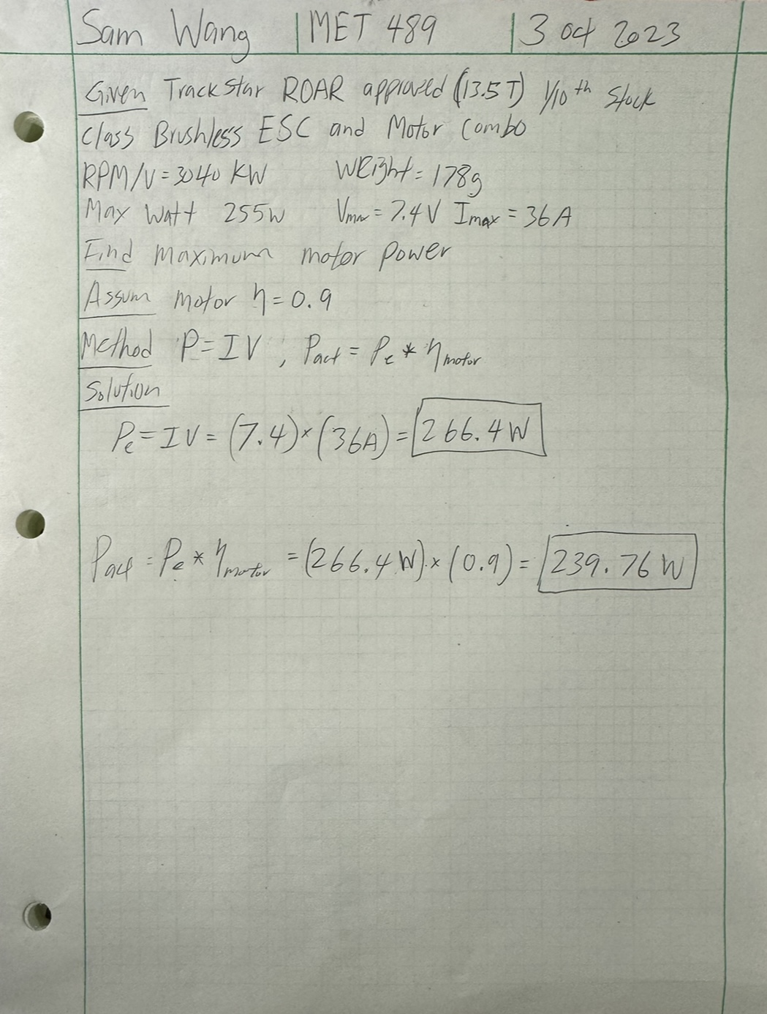

Appendix A02 – Maximum Speed

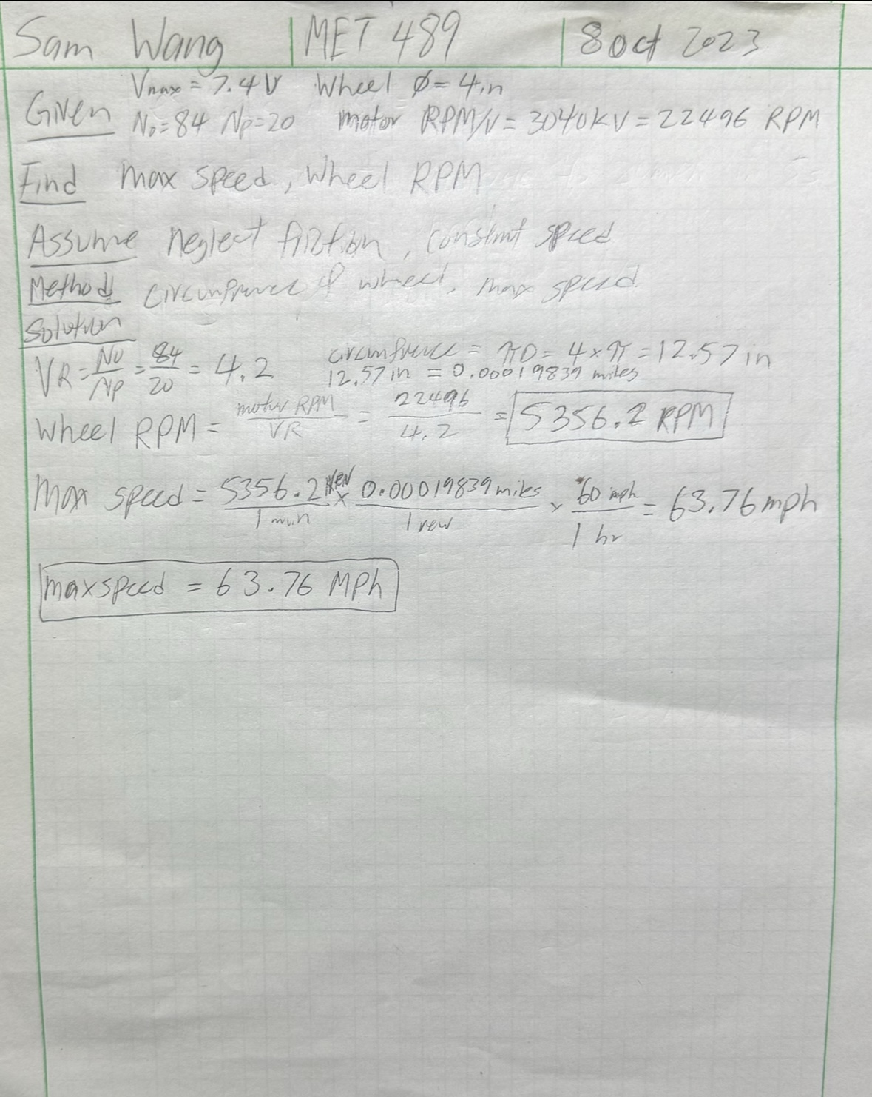

Appendix A03 – Chassis Deflection

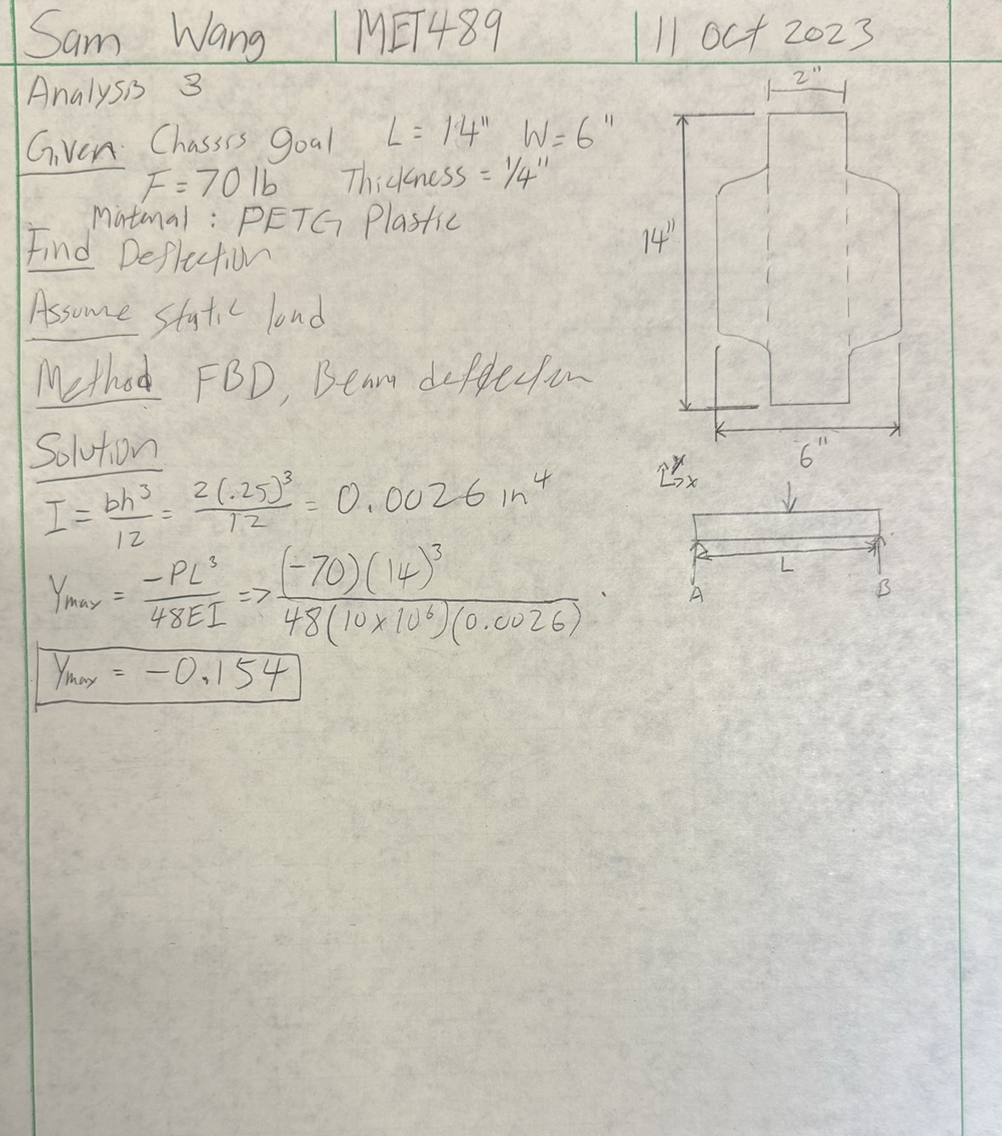

Appendix A04 – Diameter of Gear Shaft

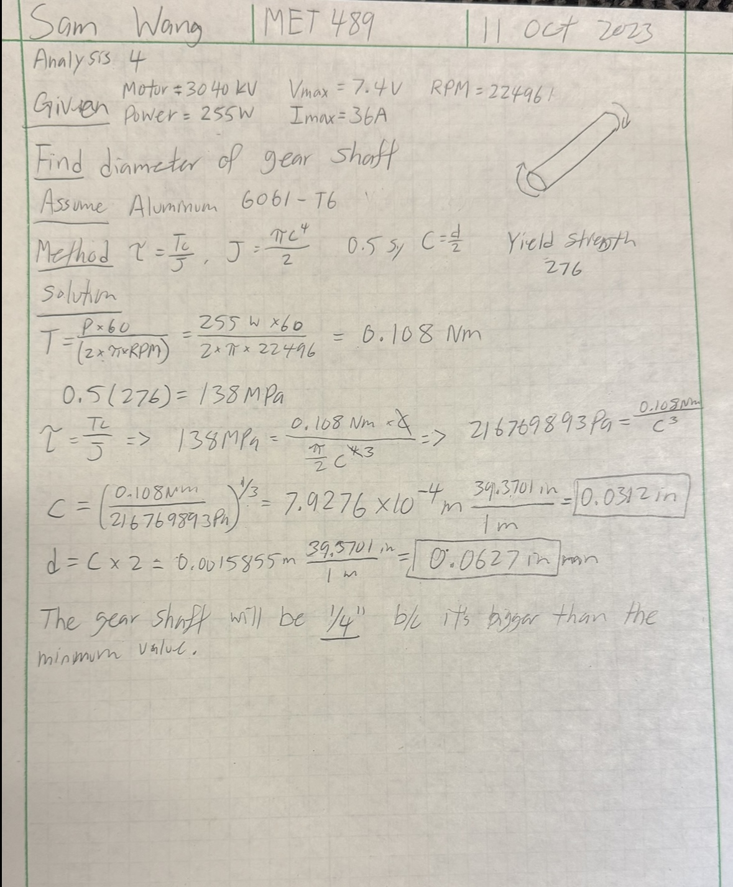

Appendix A05 – Bolt Shear Force

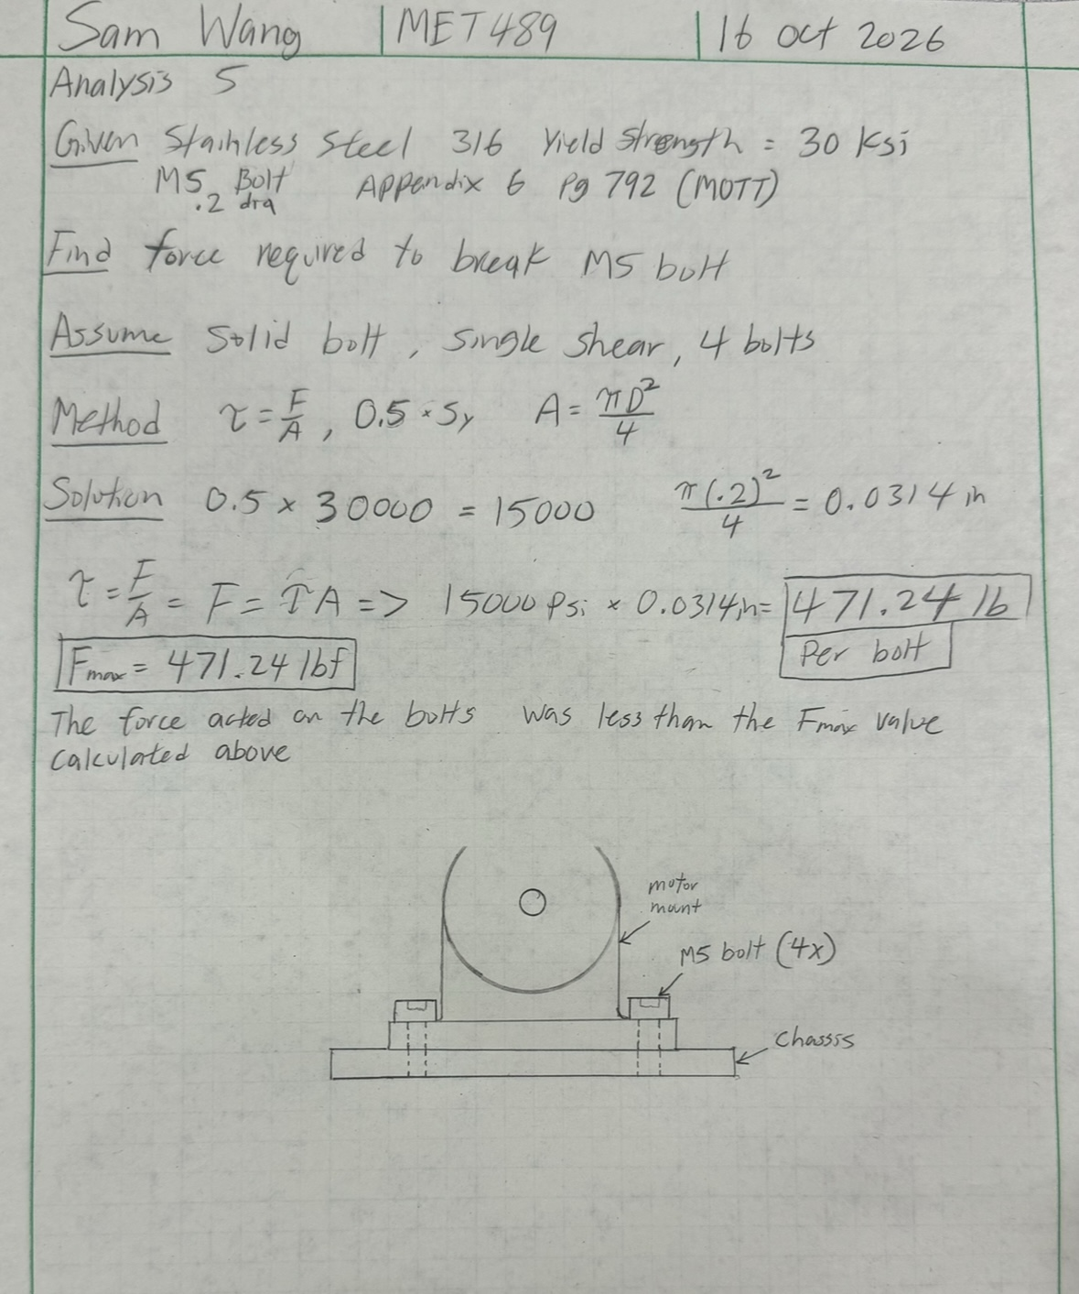

Appendix A06 – Diameter of Drive Shaft

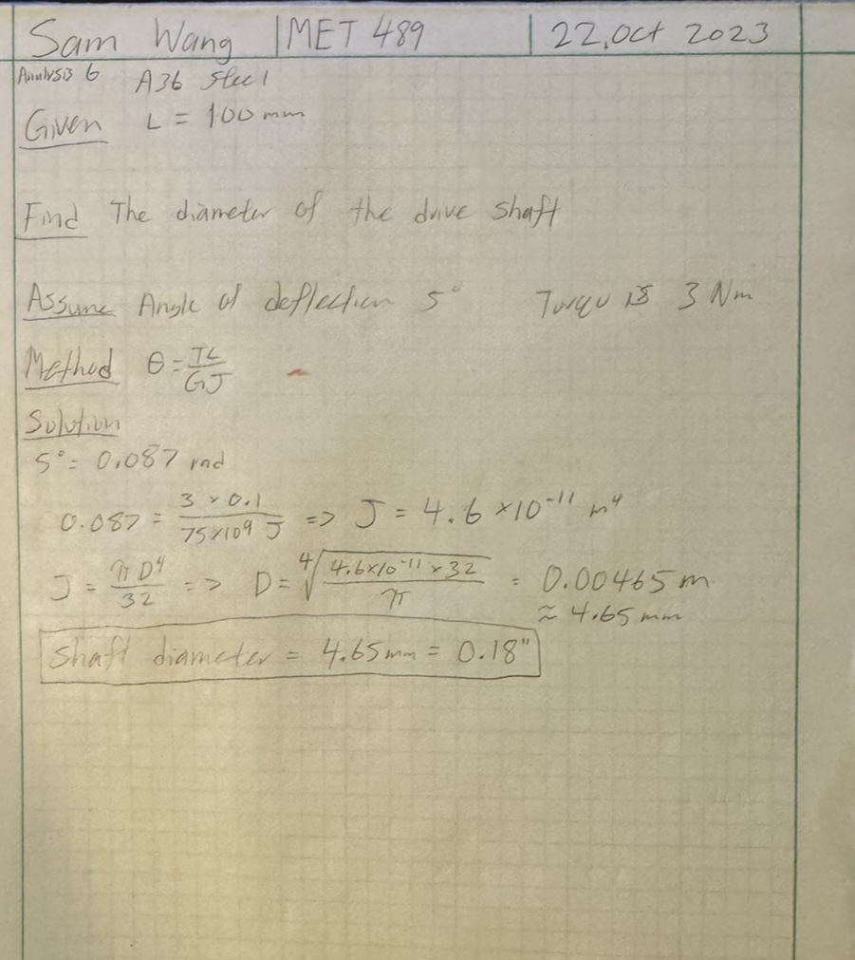

Appendix A07 – Torque Tube Size by Shear

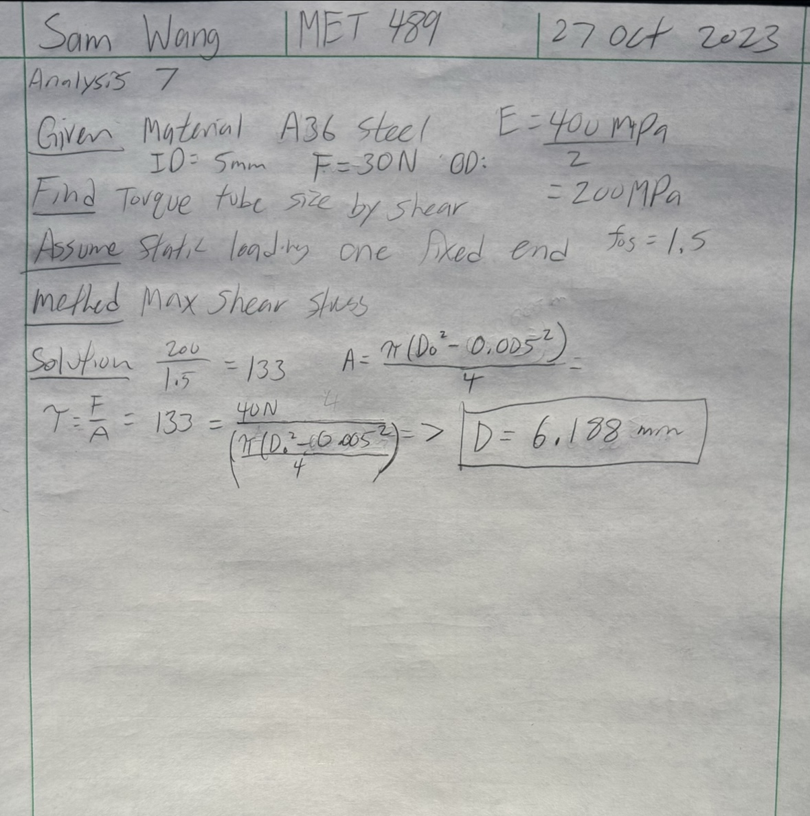

Appendix A08 – Acceleration

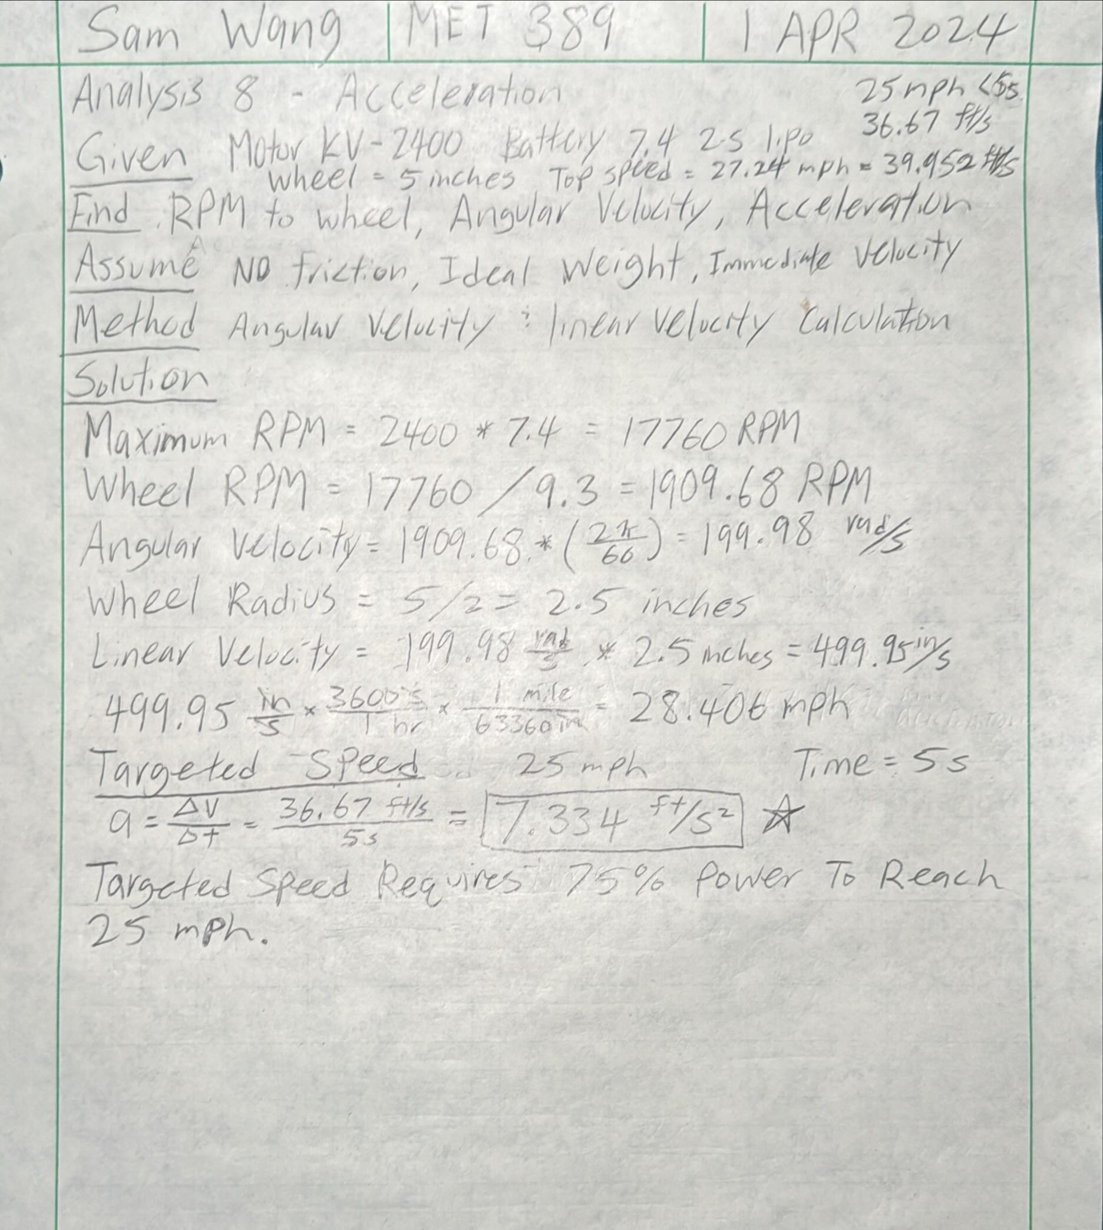

Appendix A09 – Frictional Heat from Bearing

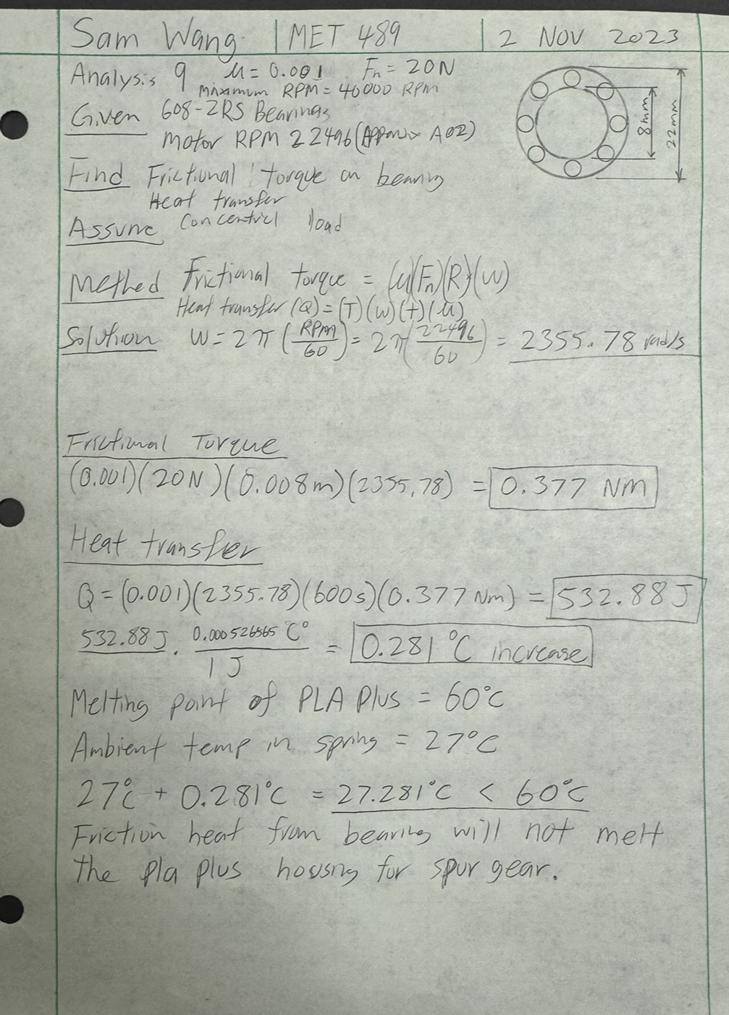

Appendix A10 – Bumper Deformation

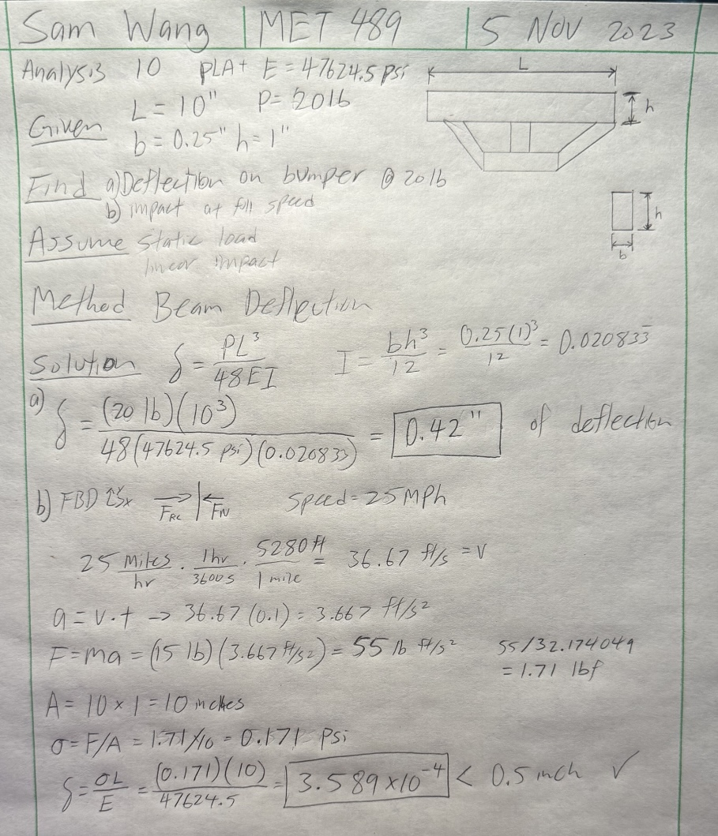

Appendix A11 – Battery Life

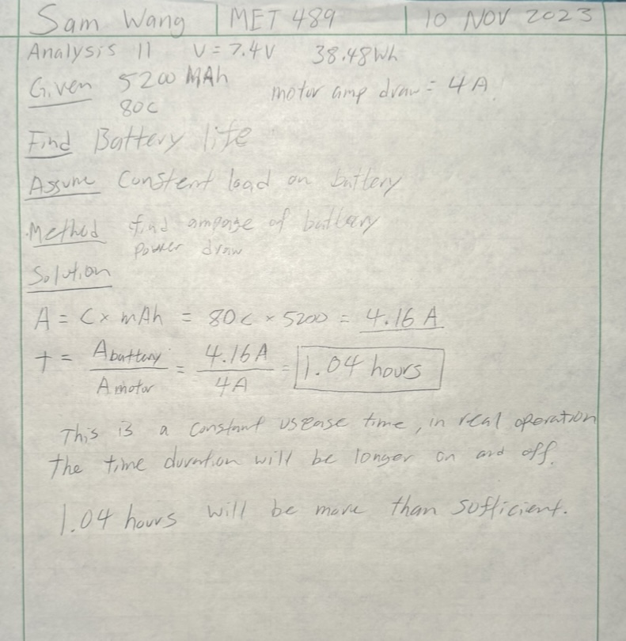

Appendix A12 – Gear Ratio and Motor Torque

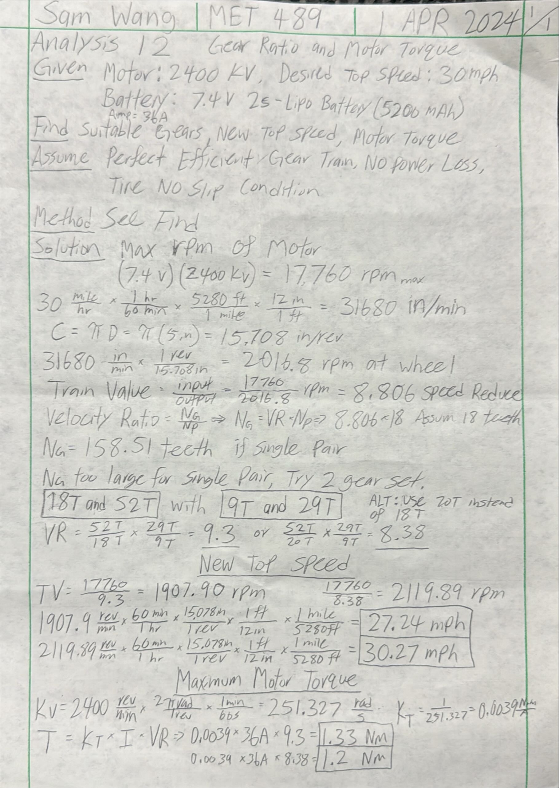

APPENDIX B - Drawings

Appendix B01 – Drawing Tree

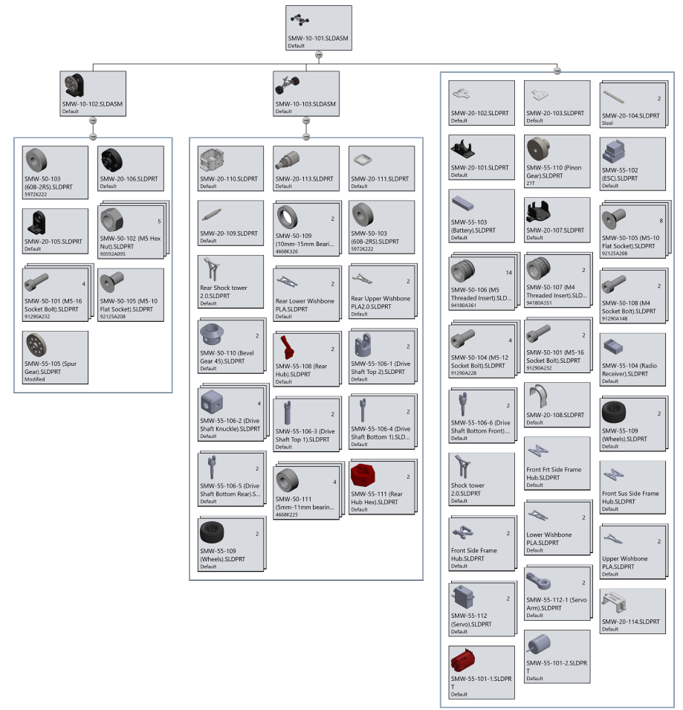

Appendix B02 – Drawing Index

Drawing Assignment Number | Drawings #(s) | Date Submitted
Upload DWG 1 | SMW-20-101 | 11 OCT 2023
Upload DWG 2 | SMW-20-102 | 18 OCT 2023
Upload DWG 3 & 4 | SMW-20-103 & SMW-20-104 | 25 OCT 2023
Upload DWG 5 & 6 | SMW-20-105 & SMW-20-106 | 1 NOV 2023
Upload DWG 7 & 8 | SMW-20-107 & SMW-20-108 | 8 NOV 2023
Upload DWG 9 & 10 | SMW-20-109 & SMW-20-110 | 15 NOV 2023
Upload DWG 11, 12, 13 | SMW-20-111 & SMW-20-112 & SMW-20-113 | 15 NOV 2023
Upload DWG 14, 15 | SMW-20-114 & SMW-20-115 | 14 NOV 2023
Upload Assembly 1 | SMW-10-101 | 8 DEC 2023
Upload Assembly 2 | SMW-10-102 | 1 DEC 2023
Upload Assembly 3 | SMW-10-103 | 2 DEC 2023

Appendix B03 – SMW-10-101 – Full Vehicle Assembly

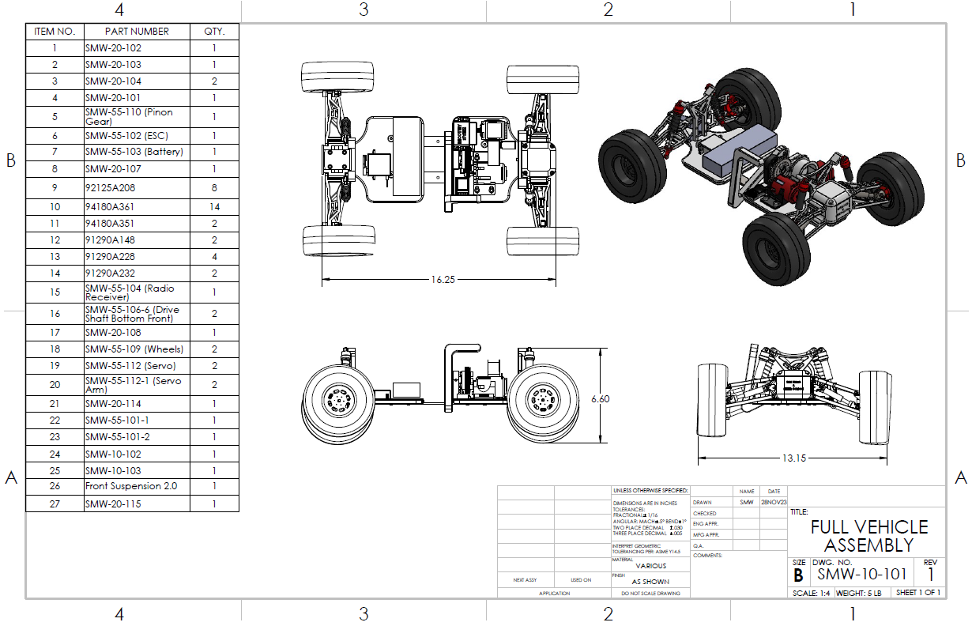

Appendix B04 – SMW-10-102 – Spur Housing Sub-Assembly

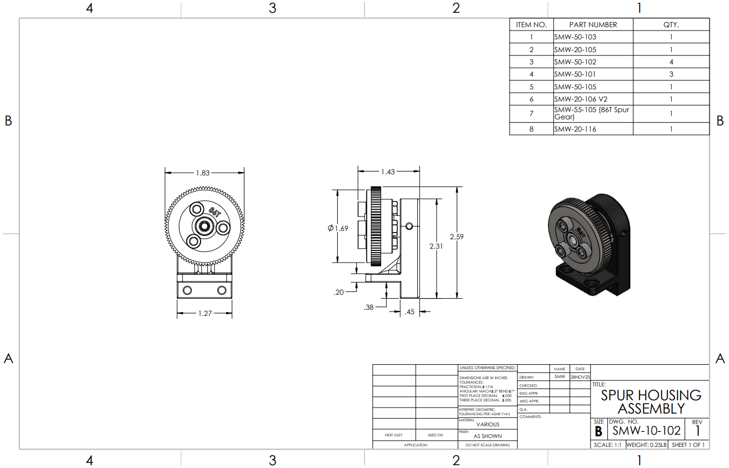

Appendix B05 – SMW-10-103 – Drive Train Assembly

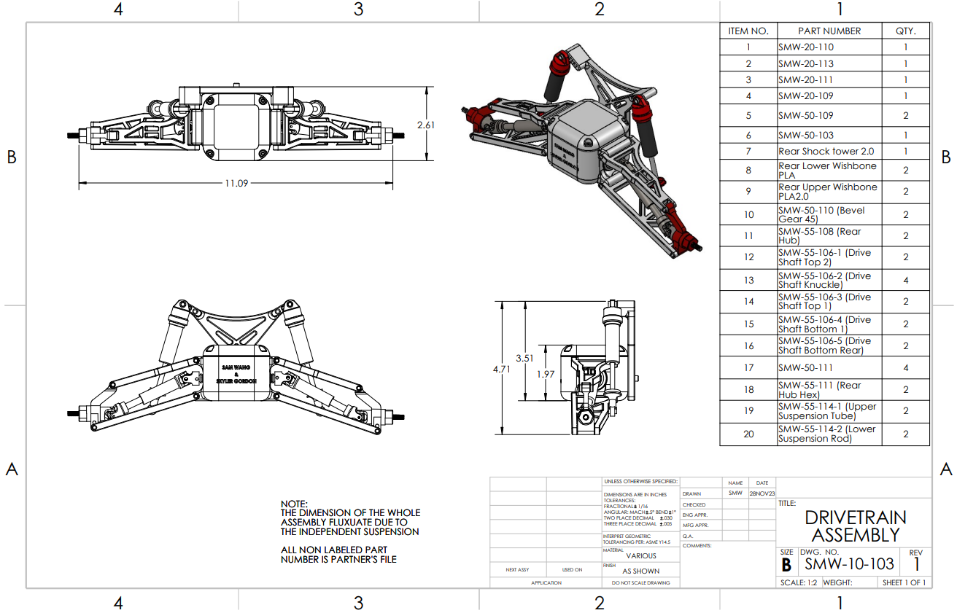

Appendix B06 – SMW-20-101 - Motor Mount
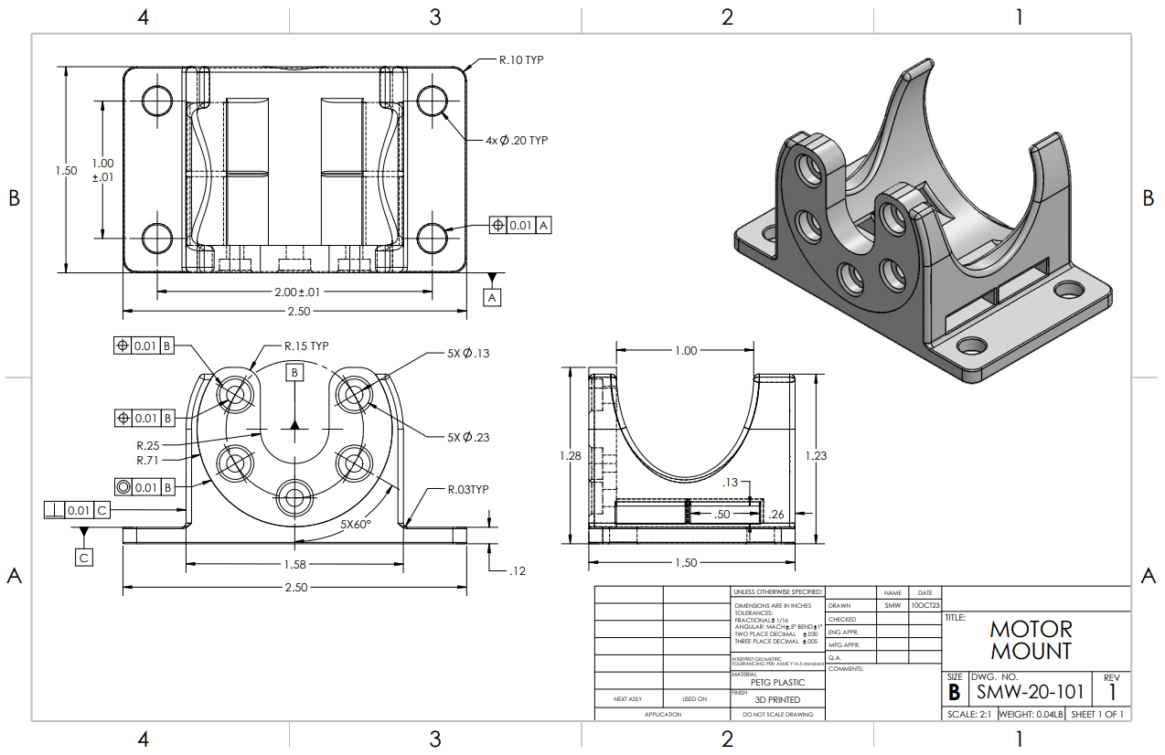

Appendix B07 – SMW-20-102 – Chassis (Rear)

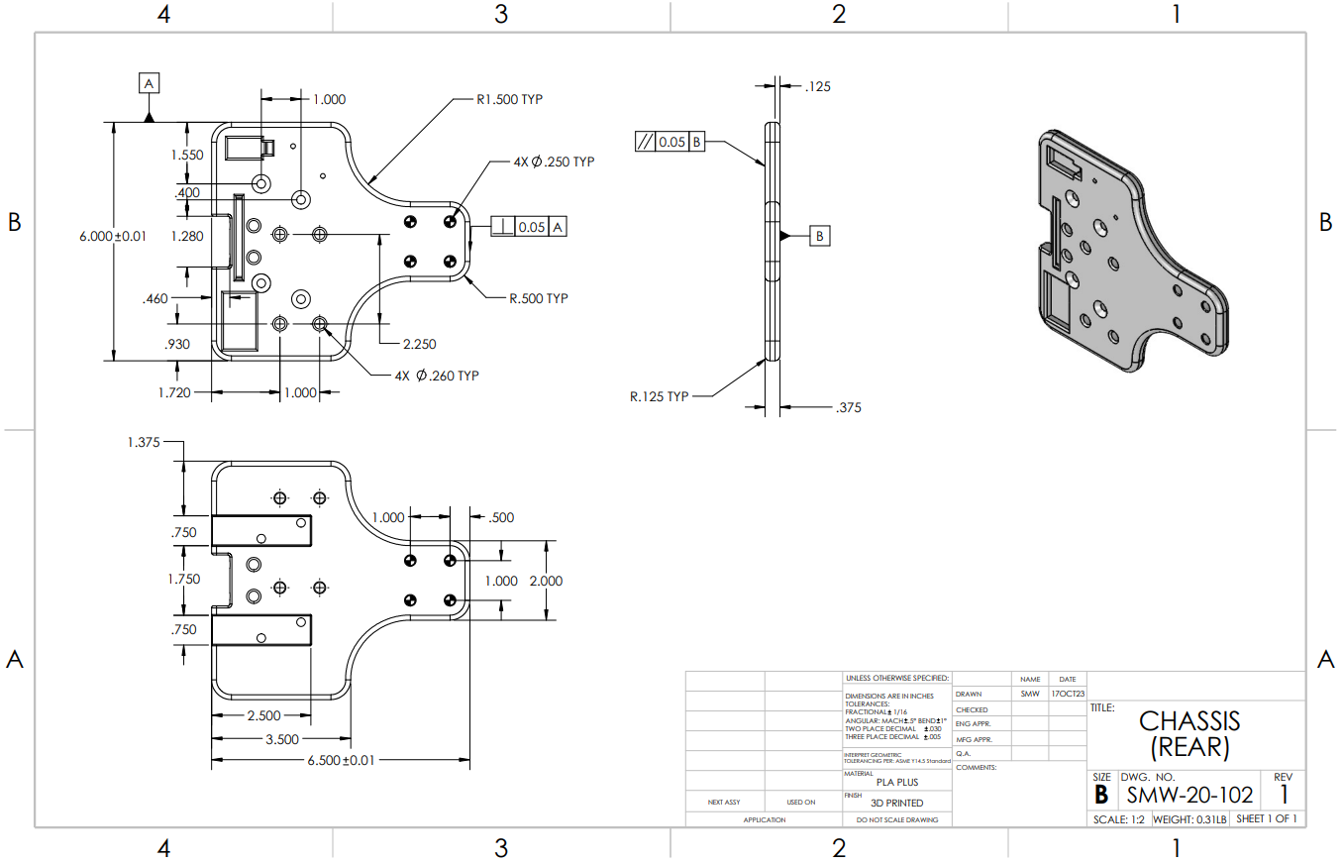

Appendix B08 – SMW-20-103 – Chassis (Front)

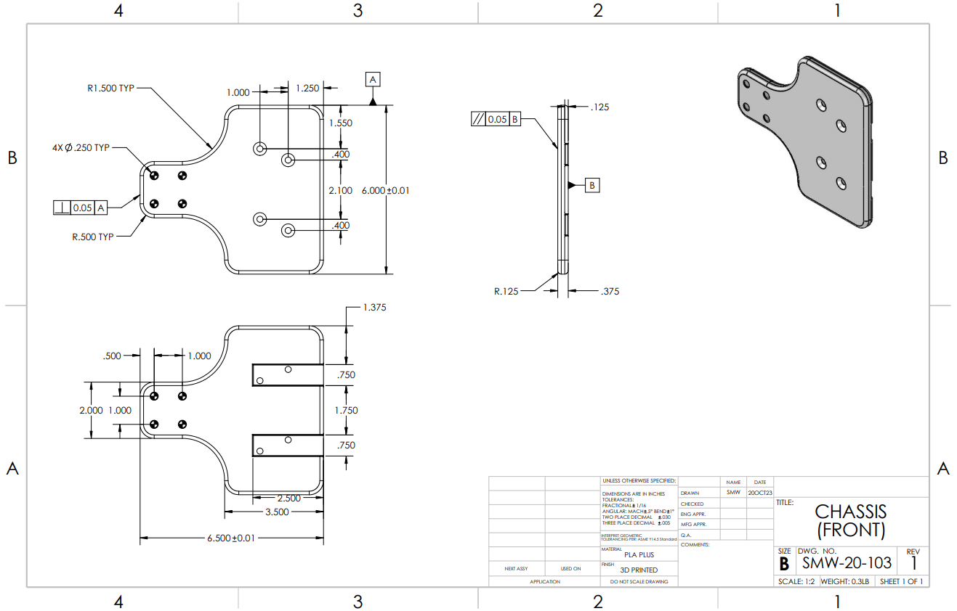

Appendix B09 – SMW-20-104 – Chassis Connecting Bar

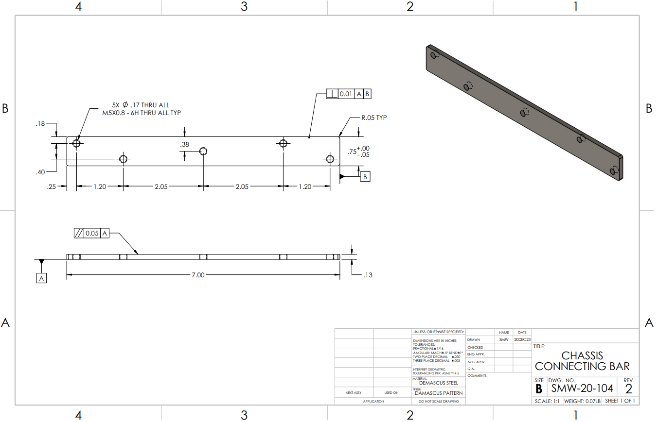

Appendix B10 – SMW-20-105 – Spur Gear Mount

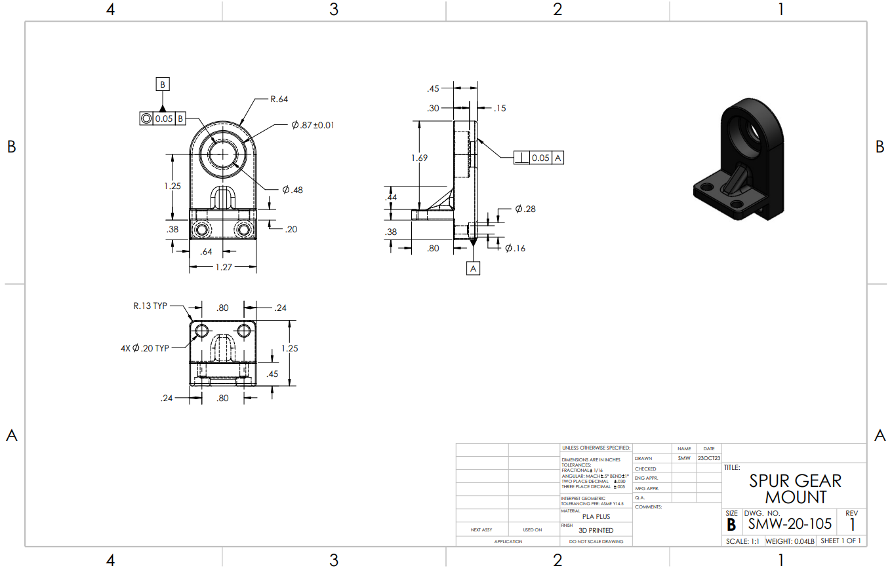

Appendix B11 – SMW-20-106 – Spur Attachment

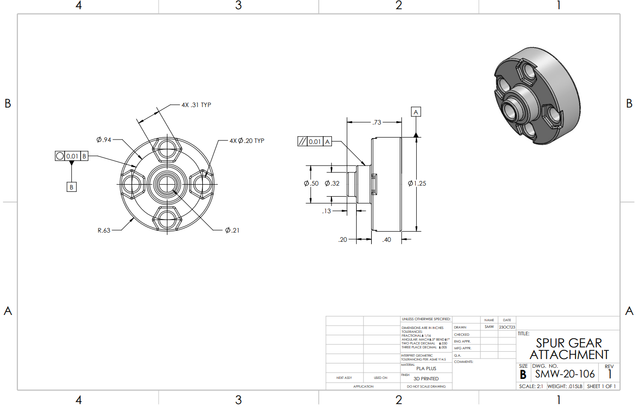

Appendix B12 – SMW-20-107 – ESC Housing

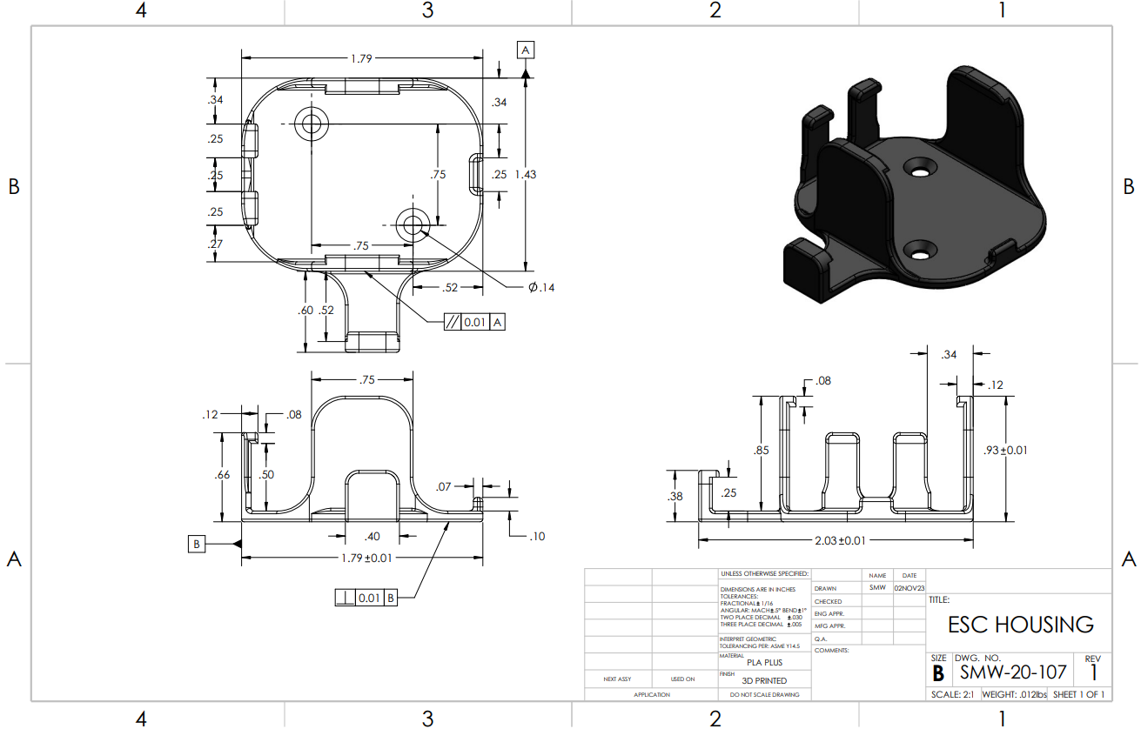

Appendix B13 – SMW-20-108 – Cable Arch

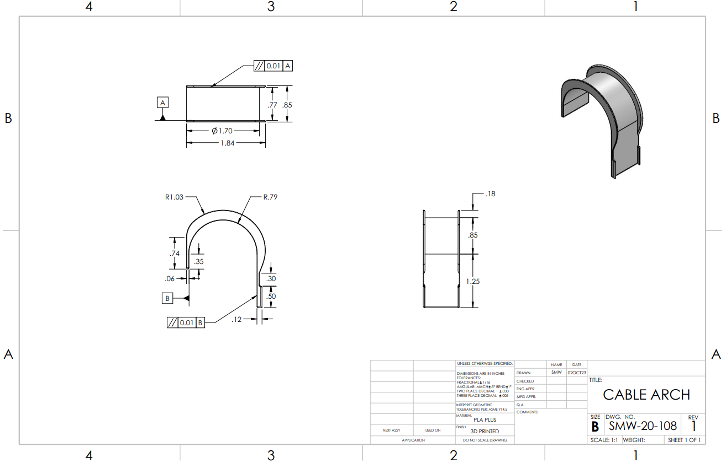

Appendix B14 – SMW-20-109 – Drive Shaft Connection

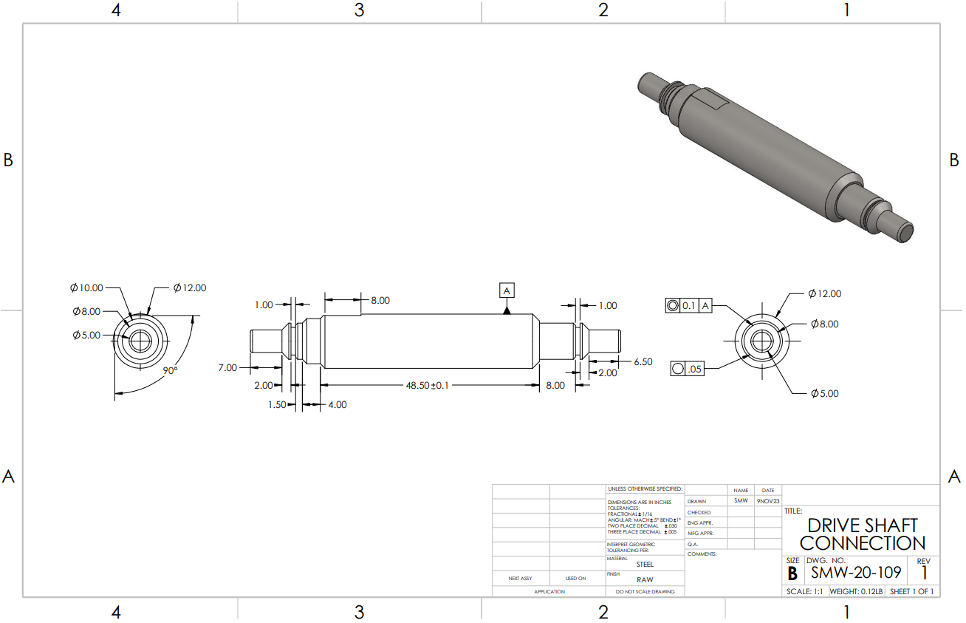

Appendix B15 – SMW-20-110 – Differential Housing (Bottom)

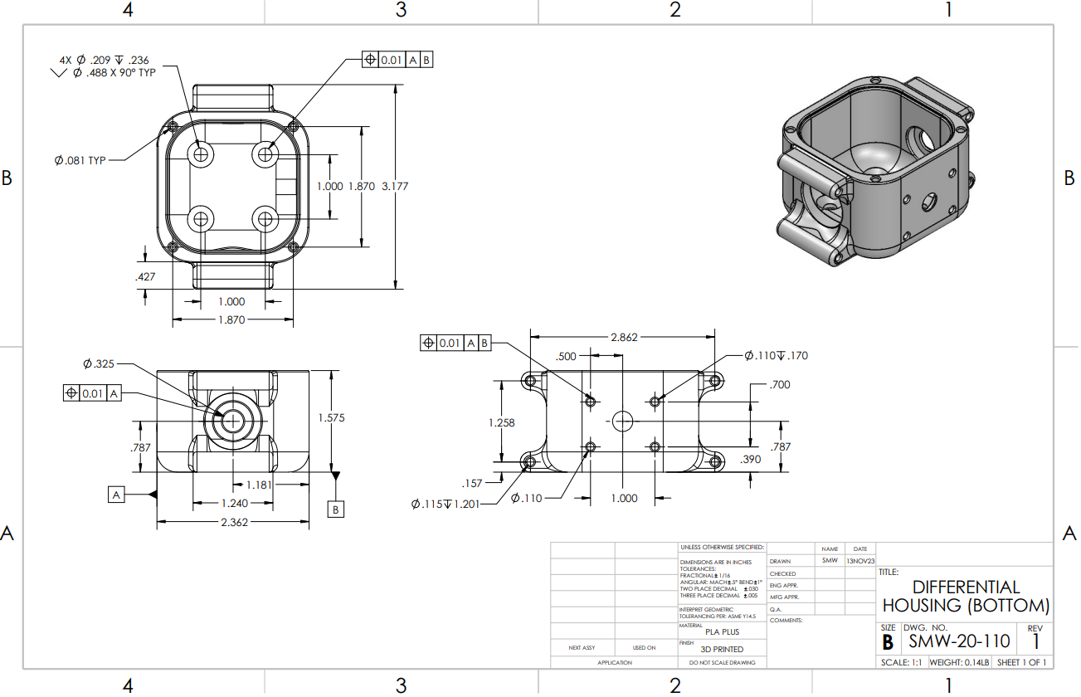

Appendix B16 – SMW-20-111 – Differential Housing (Top)

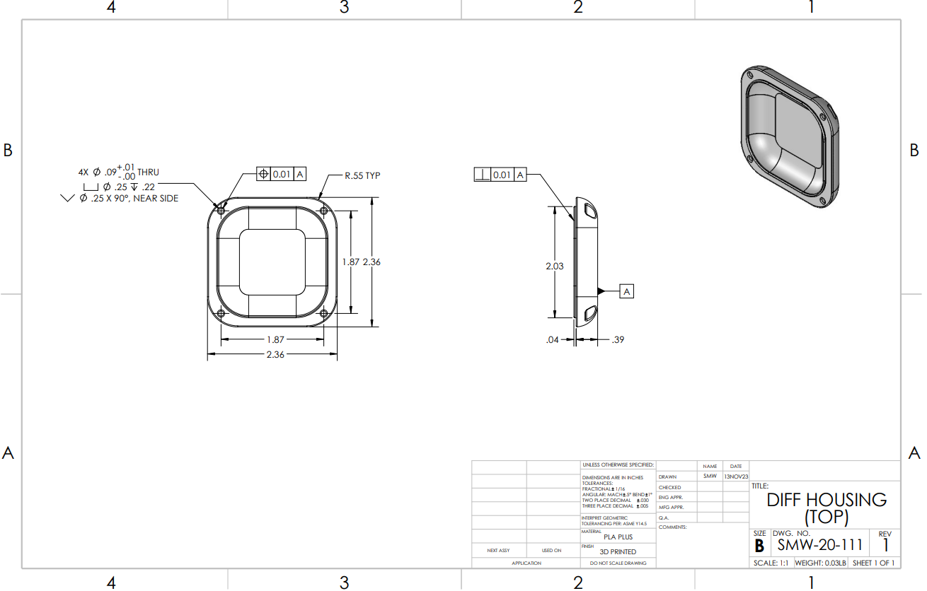

Appendix B17 – SMW-20-112 – Spur to Shaft Connection

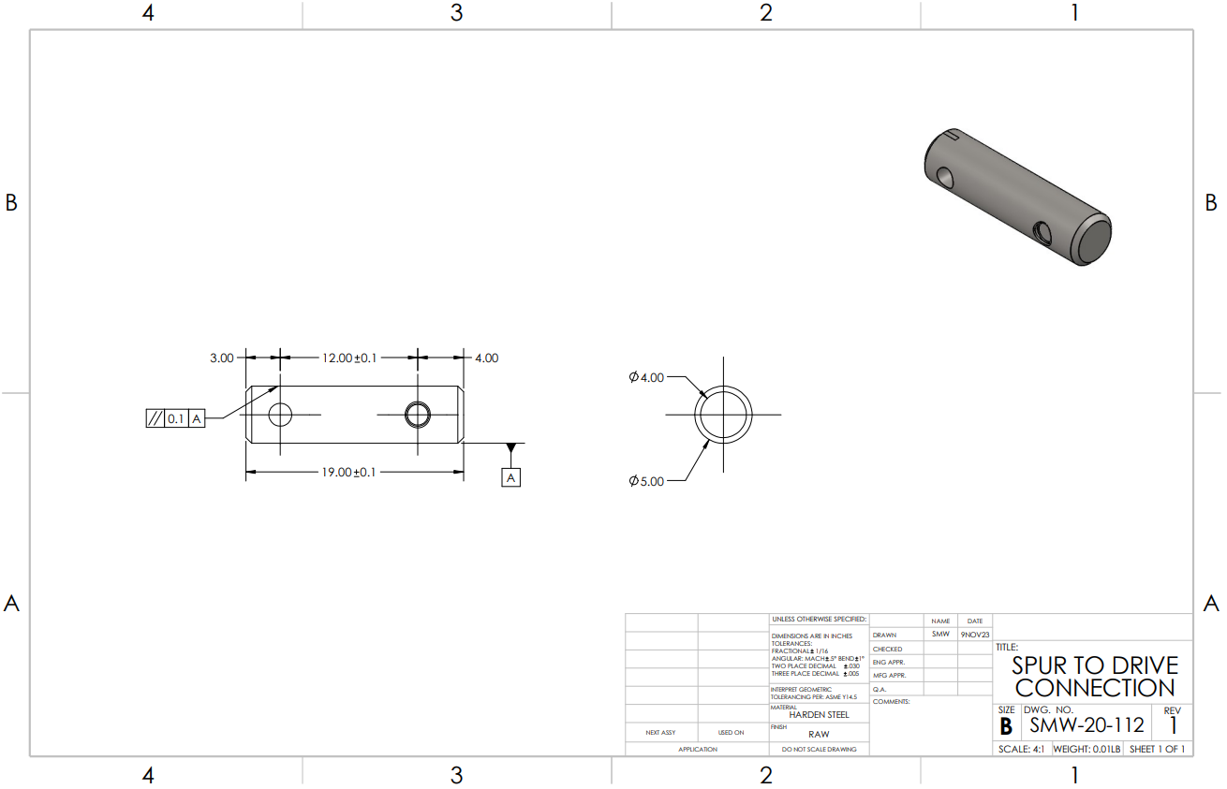

Appendix B18 – SMW-20-113 – Shaft to Diff Connection

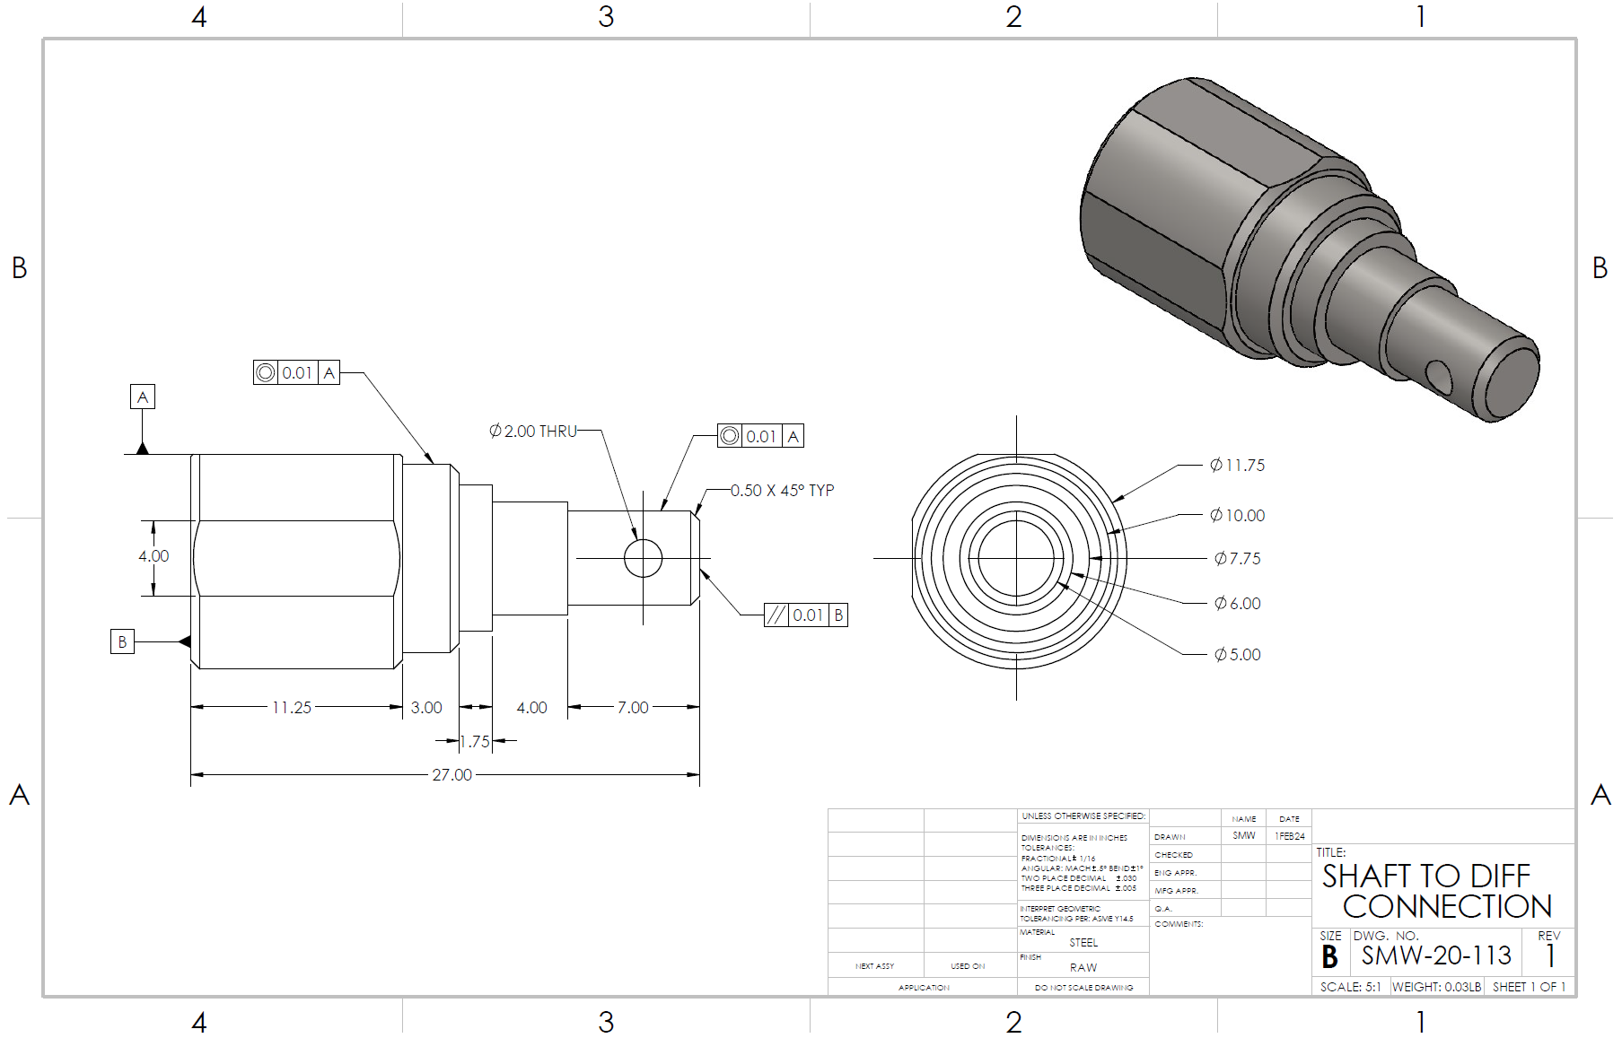

APPENDIX C – Parts List and Costs

Table C1 – Purchased Parts List

Part Number | Qty | Part Description | Source | Cost | Disposition
SMW-55-101 | 1 | Brushless Motor | HobbyKing | $45 | 10/5/2023
SMW-55-102 | 1 | ESC | HobbyKing | $45 | 10/5/2023
SMW-55-103 | 1 | Battery | HobbyKing | $26 | 10/5/2023
SMW-55-104 | 1 | Controller & Receiver | Amazon | $40 | 10/5/2023
SMW-55-105 | 1 | Spur Gear | Amazon | $16 | 10/16/2023
SMW-55-106 | 1 | Drive Shaft Front & Rear | Amazon | $27 | 10/22/2023
SMW-55-107 | 1 | Front Hub | Amazon | $20 | 10/19/2023
SMW-55-108 | 1 | Rear Hub | Amazon | $20 | 10/19/2023
SMW-55-109 | 1 | Wheels | Amazon | $27 | 10/30/2023
SMW-55-110 | 1 | Pinion Gear | Amazon | $0 | 10/16/2023
SMW-55-111 | 1 | Rear Hub Hex | Amazon | $9 | 11/1/2023
SMW-55-112 | 1 | Servo | Amazon | $17 | 11/1/2023
SMW-55-113 | 1 | Front Hub Hex | Amazon | $10 | 11/2/2023
SMW-55-114 | 1 | Shock Assembly | Amazon | $23 | 11/25/2023
Total Cost: $325

Table C2 – Fasteners

Part Number | Qty | Part Description | Source | Cost | Disposition
SMW-50-101 | 20 | M5-16 Socket Bolt | Amazon | $10 | 10/1/2023
SMW-50-102 | 20 | M5 Hex Nut | Amazon | $10 | 10/1/2023
SMW-50-103 | 1 | 208-2RS Bearing | Amazon | $2 | 10/1/2023
SMW-50-104 | 1 | M5-12 Socket Bolt | Amazon | $10 | 10/1/2023
SMW-50-105 | 2 | M5-10 Flat Socket | Amazon | $0 | 10/1/2023
SMW-50-106 | 1 | M5 Threaded Insert | Amazon | $0 | 10/1/2023
SMW-50-107 | 2 | M4 Threaded Insert | Amazon | $0 | 10/1/2023
SMW-50-108 | 2 | M4 Socket Bolt | Amazon | $0 | 10/1/2023
SMW-50-109 | 2 | 10-15mm Bearing | Amazon | $1 | 10/22/2023
SMW-50-110 | 1 | Bevel Gear | Amazon | $10 | 10/23/2023
SMW-50-111 | 4 | 5-11mm Bearing | Amazon | $1 | 10/24/2023
SMW-50-112 | 1 | 6-12mm Bearing | Amazon | $0 | 1/30/2024
Total Cost: $44

APPENDIX D – Budget

Table D1 – Project Budget

Item | Qty | Description | Cost
Manufacturing Labor | 125 | Manual Labor is $40/hr | $5000
Material | 2 | Cost of raw material. (Steel bar, PLA+ Plastic) | $82
Purchased Parts | 9 | Parts purchased to be used on the vehicle | $300
Fasteners | 40 | Socket Bolts, Hex Nuts, Washers | $100
Total Cost: $5482

APPENDIX E – Schedule

Gantt Chart: Fall Quarter
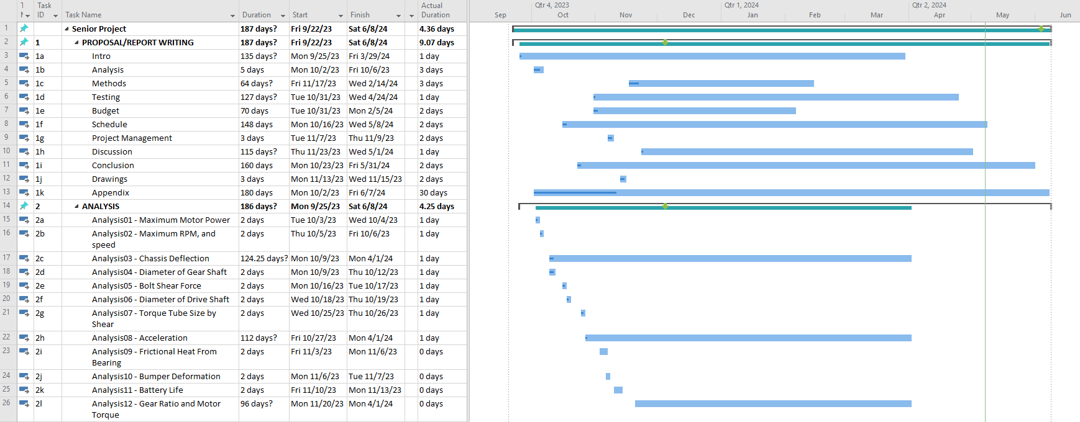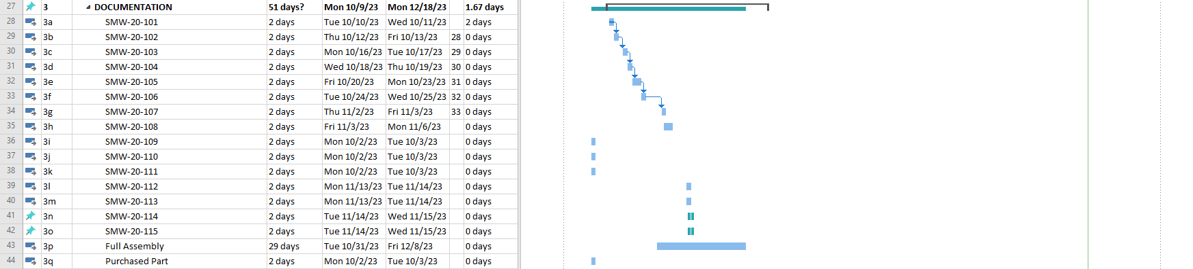

APPENDIX E – Schedule Cont.

Gantt Chart: Winter Quarter

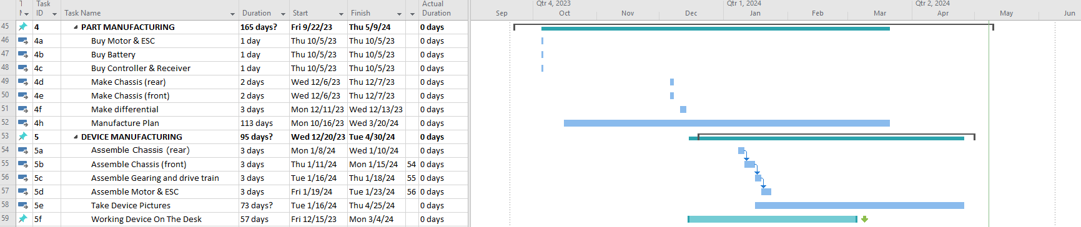

Gantt Chart: Spring Quarter

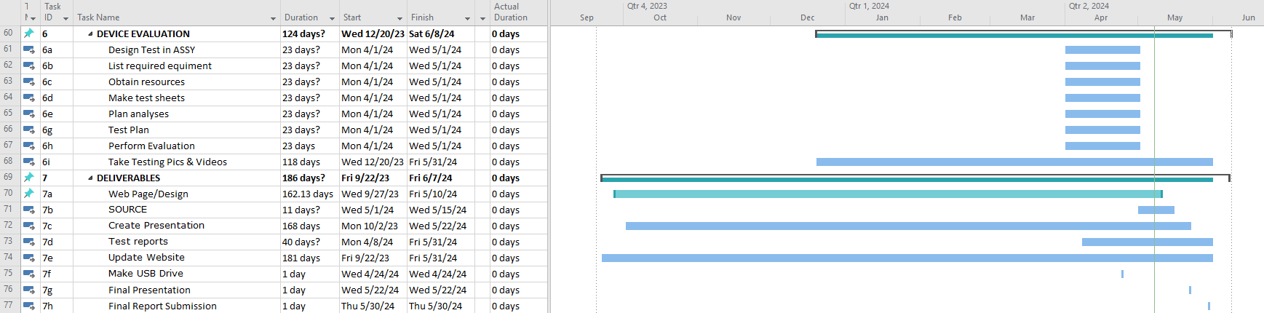

Appendix F – Expertise and Resources

Appendix F01 – Chassis Style Matrix

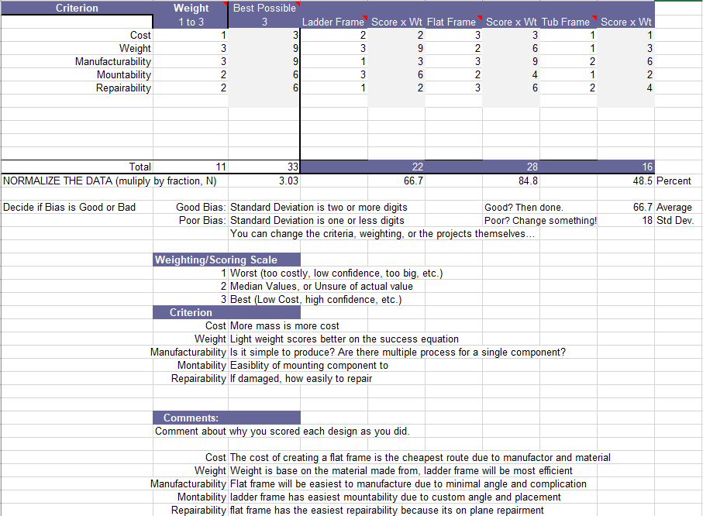

Appendix F02 – Chassis Material Matrix

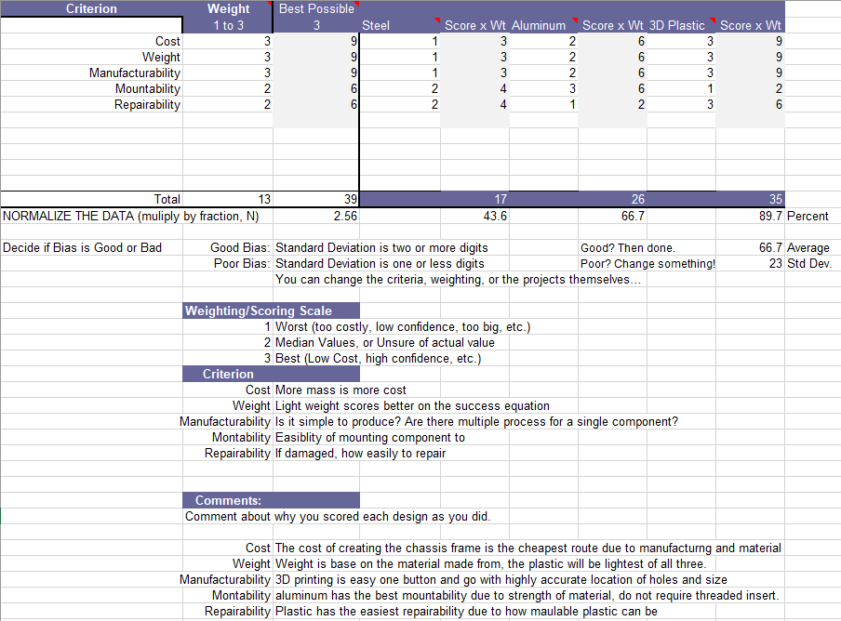

Appendix F03 – Chassis Manufacturing Matrix

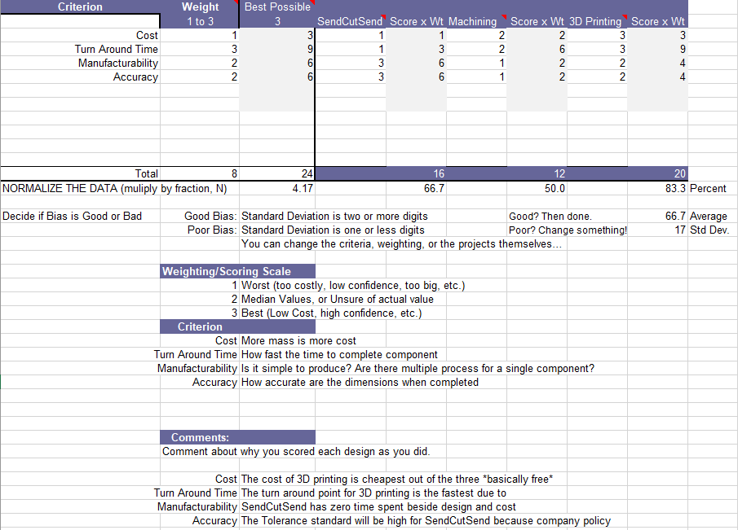

Appendix F04 – Axle Connecting Shaft Matrix

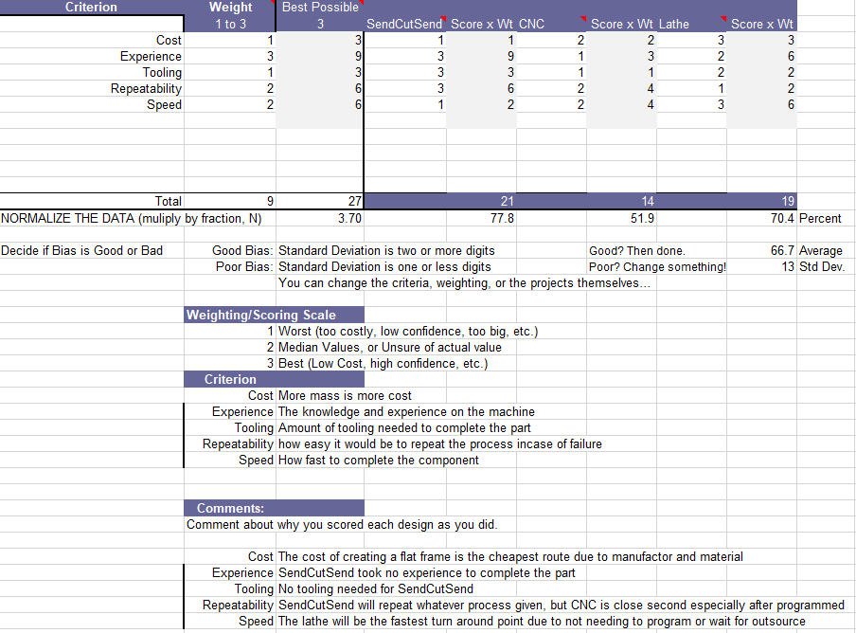

APPENDIX G – Testing Report

Appendix G1 (Top Speed)

Introduction
This procedure documents how to measure the top speed of the RC car to ensure it meets the requirements stated in 1d3, which is “the drivetrain on the vehicle will be sustainable at a speed of 25 miles per hour.”
This test is expected to take approximately 30 minutes. There will be 5 trials per power speed which is 25%, 50%, and 75%. Based on the calculation completed in Appendix A12, the top speed for the gearing ratio used, the speed will be 30.27 mph.
The high speed of the car during the test can pose a potential risk to the vehicle. If the operator does not keep the car on a safe course, it will crash and risk damaging the vehicle which would hinder any more testing of the day until a new part is manufactured. To mitigate this risk, the test will be conducted in an open environment with minimal to no obstacles that can cause crashes. Figure 12.1 is the GPS app that was used in the testing to ensure accurate data was collected for the test. The location of the testing was completed at The Verge parking lot.

Method/Approach
This test was completed by accelerating the vehicle until the top speed was reached. Using the GPS speedometer app, data can be collected with the shown values. The app provides useful information that can be used to gather the data needed. This method was used because of the simplicity of the data collected by the app allowing the engineers to record accurate data for the test. The vehicle reaches top speed in a short period of time so the trials in between the test are quick and efficient.

Test Procedure
Summary: The speed testing of an RC Baja car involves meticulous preparation and execution in a controlled environment. With safety as a top priority, the car's top speed is measured using GPS technology. By adhering to safety protocols and analyzing the collected data, engineer gain valuable insights into the RC car's performance capabilities.
Time: The test was conducted on 4/15/2024 from 1pm to 2pm at The Verge parking lot. The setup time took 5 minutes with 30 minutes to conduct the testing and it took 5 minutes to take down. The data collected were screen shotted and the time was recorded on a piece of engineering paper. All speed raw data was later reviewed and organized using Microsoft Excel.
Location: The Verge Parking Lot (Dry)
Required Equipment Includes:
- RC Baja
- iPhone with GPS speedometer app
Risk: When testing the speed of an RC Baja car, it's important to be aware of potential risks such as collisions, loss of control, and damage to the vehicle or surroundings. Safety measures, including selecting an appropriate location, wearing protective gear, and following operational guidelines, are crucial for minimizing these risks and ensuring a safe testing environment.

The test procedure is as follows:
- Download GPS Speedometer app on the app store
- Secure the phone onto the vehicle using the mount. (Top mount for most accurate data)
    - Use duct tape or zip tie if needed
- Open the app and zero out all the data
- Align the RC Baja on the start line pointed down the empty straight away
- Press start on the app and step back
- Accelerate the car in a fast straight safety manner
    - Slowly increase trigger till full throttle
    - Adjust steering if needed to keep it linear
- Stop the vehicle when it has reached the top speed without loss of control
- Return the vehicle to the recorder
- Press stop on the app and take a screen shot
- Repeat step 4 to 9 as many times as desired (minimum of 3)
    - more trial = more accurate data
- Review and transfer all the raw data from the app/screenshot onto Microsoft excel
    - The data shown on figure 12.1
- Compare all the trials and find the higher number to determine the top speed
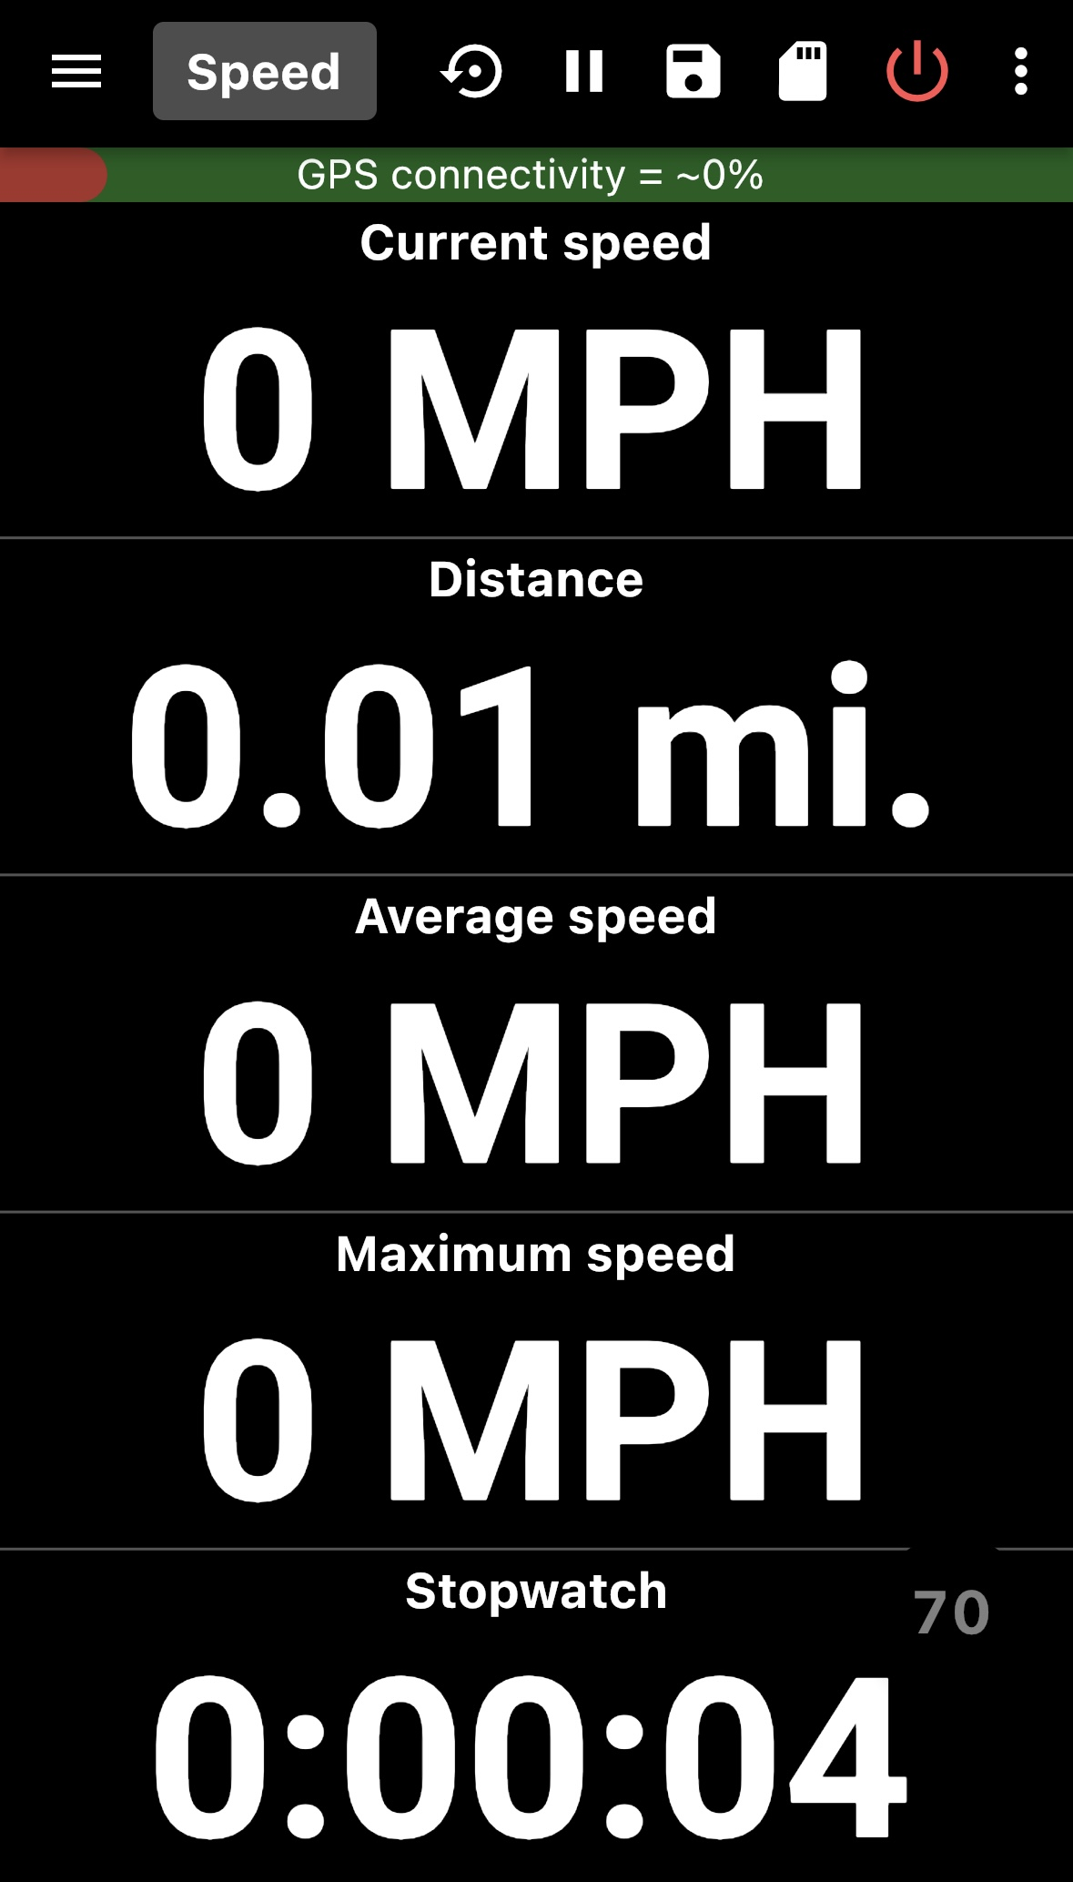
Figure 12.1

Deliverables

Appendix G1.1 – Procedure Checklist

Appendix G1.2 – Data Forms

Appendix G1.3 – Raw Data

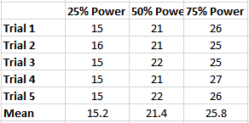
Figure 12.2

Appendix G1.4 – Evaluation Sheet

Appendix G1.5 – Schedule (Testing)

Appendix G2 (Acceleration from Stop)

Introduction
This procedure documents how to measure the acceleration of the RC car to ensure it meets the requirements stated in 1d19, which is “Accelerate to 20 mph in less than 10 seconds.”
This test is expected to take approximately 30 minutes. There will be 5 trials per power speed which is 25%, 50%, and 75%. Based on the calculation completed in Appendix A08, the top acceleration the motor in perfect condition is capable of reaching 7.334 ft/s^2.
The high speed of the car during the test can pose a potential risk to the vehicle. If the operator does not keep the car on a safe course, it will crash and risk damaging the vehicle which would hinder any more testing of the day until a new part is manufactured. To mitigate this risk, the test will be conducted in an open environment with minimal to no obstacles that can cause crashes. Figure 12.1 is the GPS app that was used in the testing to ensure accurate data was collected for the test. The location of the testing was completed the parking lot behind the fluke lab.

Method/Approach
This test was completed by accelerating the vehicle in a set distance of 50 ft. Using the GPS speedometer app, data can be collected with the shown values. The app provides useful information that can be used to gather the data needed. This method was used because of the simplicity of the data collected by the app allowing the engineers to record accurate data for the test. The vehicle reaches top speed in a short period of time with a short course distance, so the trials in between the test are quick and efficient.

Test Procedure
Summary: The speed testing of an RC Baja car involves meticulous preparation and execution in a controlled environment. With safety as a top priority, the car's acceleration is measured using GPS technology and the timer location in the app. By adhering to safety protocols and analyzing the collected data, engineer gain valuable insights into the RC car's performance capabilities.
Time: The test was conducted on 4/23/2024 from 4pm to 5pm at the parking lot behind the fluke lab. The setup time took 5 minutes with 30 minutes to conduct the testing and it took 5 minutes to take down. The data collected were screen recording and the time was recorded on the app through the screen recording. All raw data was collected on an engineer paper and later organized and calculated using Microsoft Excel.
Location: The parking lot behind the fluke lab (Dry)
Required Equipment Includes:
- RC Baja
- iPhone with GPS speedometer app
Risk: When testing the acceleration of an RC Baja car, it's important to be aware of potential risks such as collisions, loss of control, and damage to the vehicle or surroundings. Safety measures, including selecting an appropriate location, wearing protective gear, and following operational guidelines, are crucial for minimizing these risks and ensuring a safe testing environment.

The test procedure is as follows:
- Download GPS Speedometer app on the app store
- Secure the phone onto the vehicle using the mount. (Top mount for most accurate data)
- Use duct tape or zip tie if needed
- Open the app and zero out all the data
- Align the RC Baja on the start line pointed down the empty straight away
- Start screen recording and press start on the app and step back
- Accelerate the car in a fast straight safety manner
  - Fast but controlled, increase trigger till full throttle
  - Adjust steering if needed to keep it linear
- Stop the vehicle when it has reached the stopping line without loss of control
- Repeat the drive on the way back
- Return the vehicle to the recorder
- Press stop on the app and end recording
- Repeat step 4 to 11 as many times as desired (minimum of 3)
  - more trial = more accurate data
- Review the time by watching the screen recording frame by frame and counting the seconds throughout the acceleration.
- Transfer all the raw data from the app/screen recording onto Microsoft Excel
  - The data shown on figure 12.1
- Calculate the average velocity and acceleration on Microsoft Excel to get desired values.

Deliverables

Appendix G2.1 – Procedure Checklist

Appendix G2.2 – Data Forms

Appendix G2.3 – Raw Data
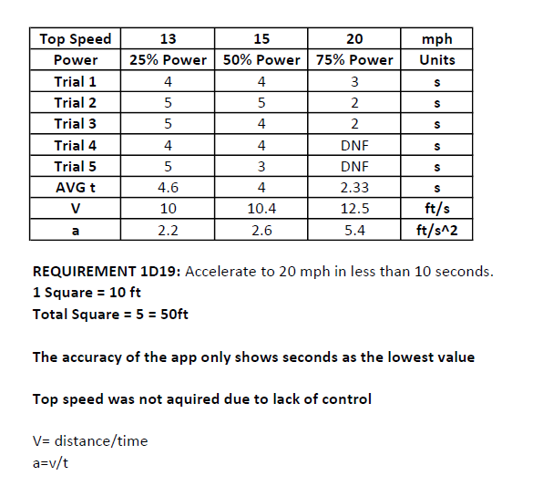
Figure 12.3

Appendix G2.4 – Evaluation Sheet

Appendix G2.5 – Schedule (Testing)

Appendix G3 (Chassis Deflection)

Introduction
This procedure documents how to measure the chassis deflection of the RC car to ensure it meets the requirements stated in 1d12, which is “Chassis deflection no more than half of inch with 20lbs.” This test is expected to take approximately 40 minutes. There will be 5 trials of the 20 lb load and 3 trials of loads until half an inch deflection. Based on the calculation the chassis deflection calculation completed in Appendix A03.
The testing of the deflection test is relatively safe but it can pose a potential risk of the chassis flying out of the Instron due to improper placement. To mitigate this task, the fixture was properly fixed down to the machine and the chassis was placed property at the support ends Shown in Figure 12.5.

Method/Approach
This test was completed by testing the chassis deflection on the Instron with the poundage set to 20, as well as setting the deflection to half an inch. All data was captured in the Bluehill Element program, it provides raw data for each trial and the graph as well. This program was convenient with everything set out for ease of data access making it a great tool to use. This method was used because of the convenience and simplicity of the data collection on the program. The time between trials are relatively quick making the testing time fast.

Test Procedure
Summary: The chassis deflection testing of an RC Baja car involves meticulous preparation and execution in a controlled environment. With safety as a top priority, the car's chassis deflection was measured using the Instron located in room 127 in Hogue. By adhering to safety protocols and analyzing the collected data, engineer gain valuable insights into the RC car's chassis capabilities.
Time: The test was conducted on 5/3/2024 from 9:30am to 10:15pm in room 127. The setup time took 5 minutes with 30 minutes to conduct the testing and it took 5 minutes to take down. The data collected were all in the program making it easy to export the raw data. The raw data exported includes all the trials and the graphs and numbers.
Location: Room 127 in Hogue Building
Required Equipment Includes:
- RC Baja
- Instron Machine with Fixture
- Safety Glasses
Risk: When testing the chassis deflection of an RC Baja car, it's important to be aware of the potential risk of the testing material flying out due to improper placement. Safety measures, including double checking the point of contacts on the chassis placement and wearing safety glasses in case the material flies at you, wearing protective clothing, and following operational guidelines, are crucial for minimizing these risks and ensuring a safe testing environment.

The test procedure is as follows:
- Go to room 127 located in Hogue at CWU
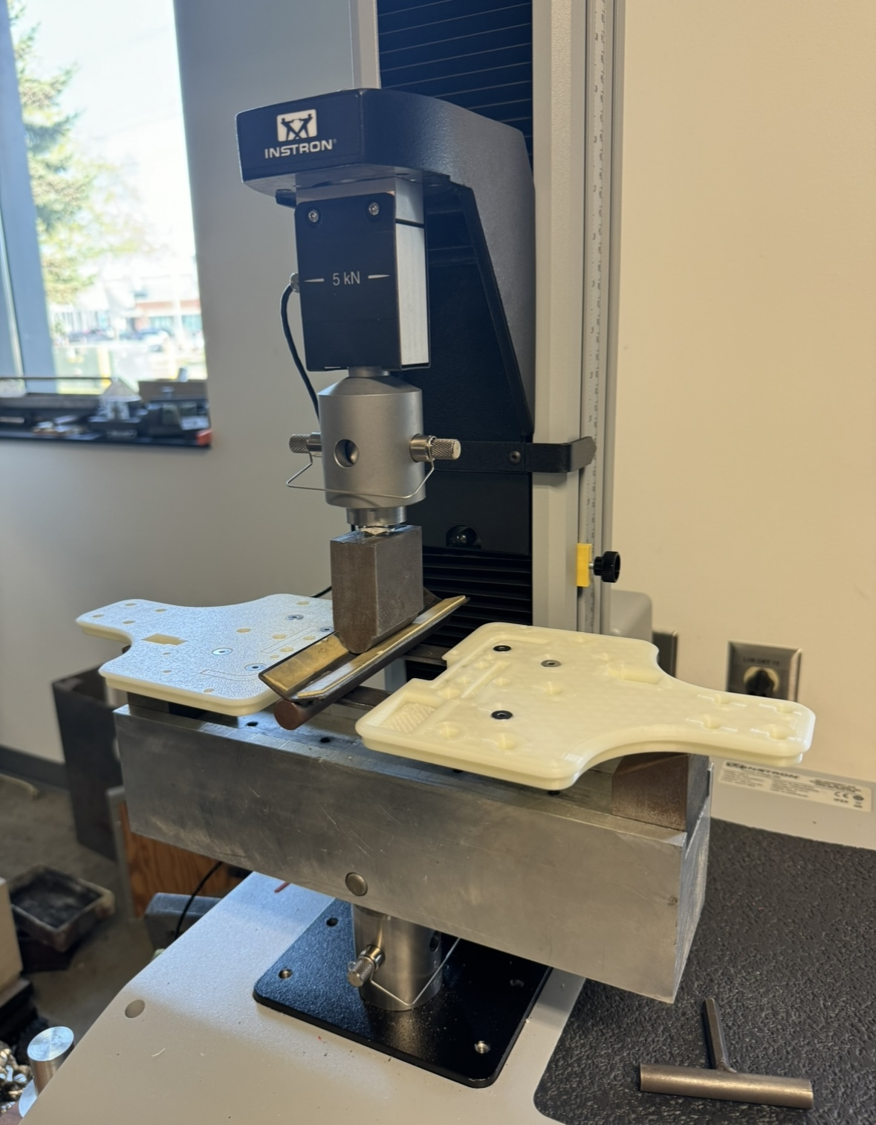
- Locate the Instron machine in the back right corner of the room and turn it on by flipping the switch in the back of the machine

- Log into the computer next to it and wait for everything to boot up
- Find “Bluehill Elements” app and open it
- Log into the app with the user ID provided by Professor Pringle
  - The app should automatically connect to the machine
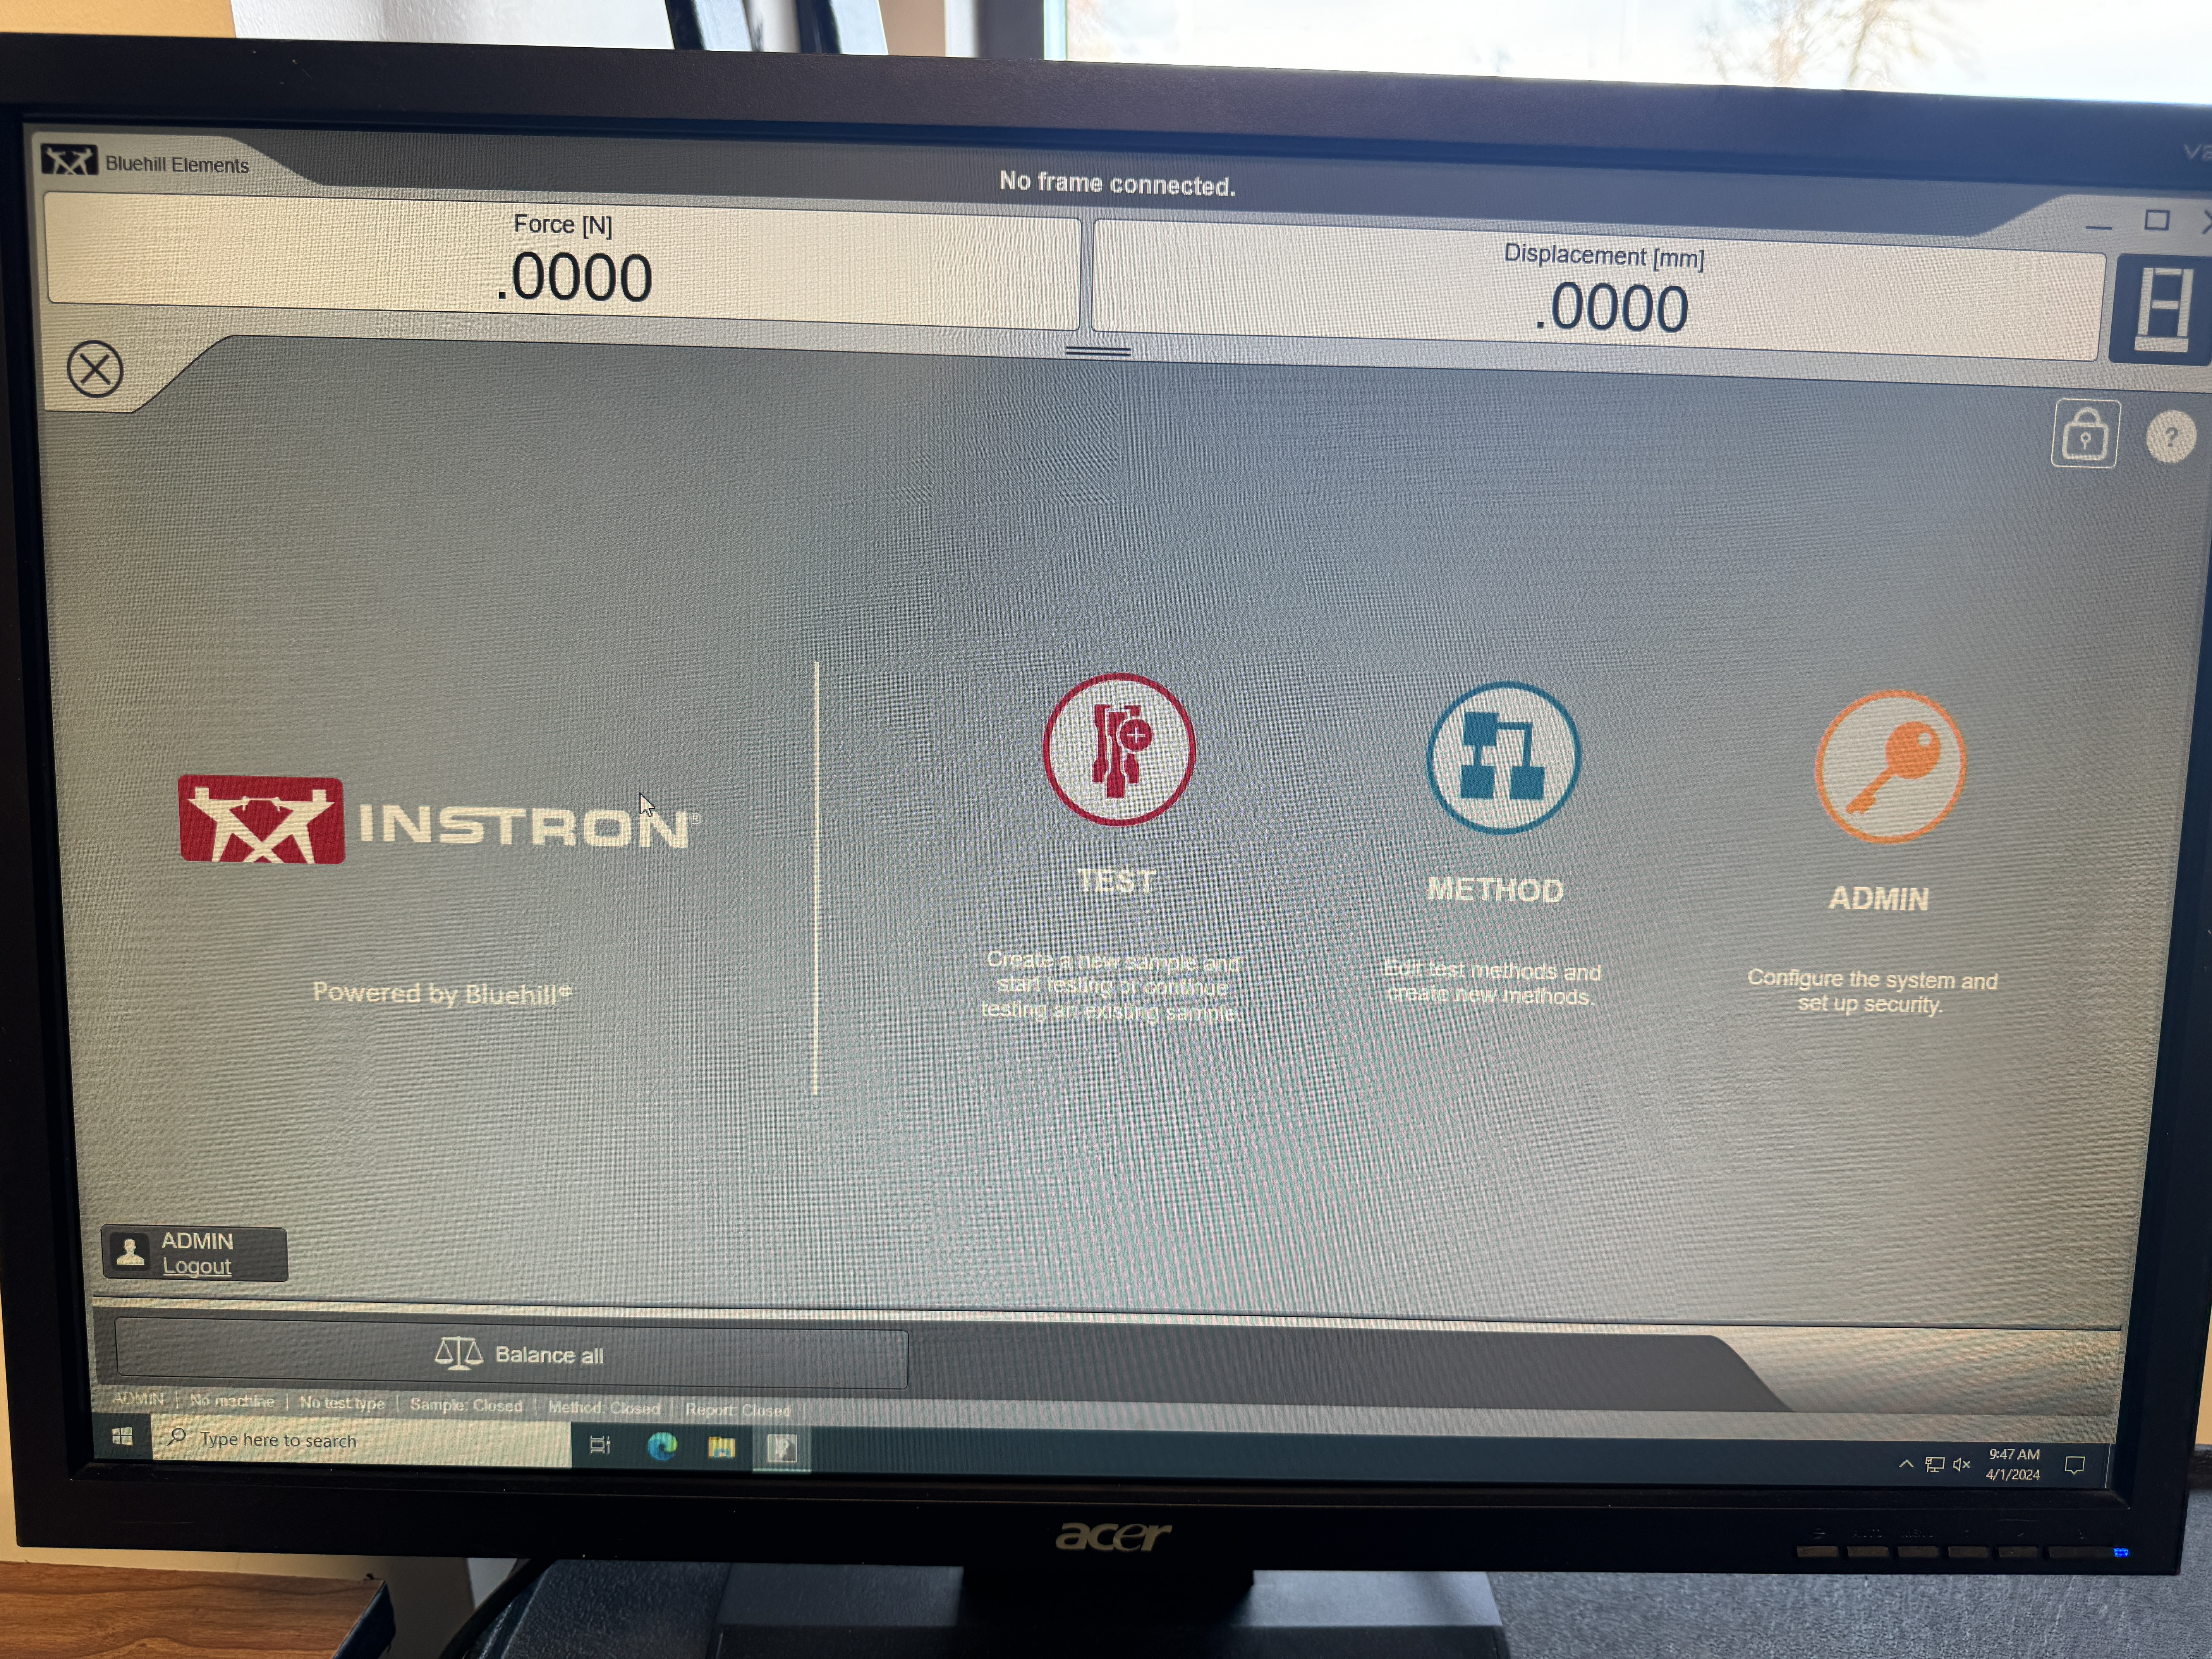
- Once logged into the desktop station, acquire the lower stationary supports (simply supported ends) that are shown in figure 12.5 and mount the supports the closet inwards that they can go and take a 4mm allen wrench to fasten each screw that the support uses to fasten into the base. (These screws do not need to be tightened very hard, just get them snug)
Figure 12.4
- Fasten the testing fixture base to the Instron by putting the snap pin through the fixture and Instron. (Shown in Figure 12.5)
Figure 12.5
- Acquire the top testing fixture, this will simulate a concentrated point load onto the test piece. This is put onto the Instron by taking a snap pin and putting it through the testing fixture and Instron. (Shown in Figure 2.5)
Figure 12.6
- Now that the testing environment has been setup, go back to the desktop. A screen showing “TEST”, “METHOD”, and “ADMIN” will be present, click “TEST” to begin testing and get to settings/scenario choices. (Compression) (See Figure 12.6)
  - Select “Quick Test”
- Load the test sample (Chassis) into the Instron, lay it in flat orientation so that it is evenly supported by the testing fixture base at both ends (simply supported ends) (Max 10.5 inches).
- Select the test prediction to be “compression.”
- Finally, lower the fixture that simulated the point load so that it is just barely touching the top surface of the trailing arm, and then click “Balance all” on the desktop so that force and displacement are equal to 0. Then set sample test speed to 0.5 in/min.
- The test is now ready to begin, first, make sure approved eye pro is being worn correctly, and all belongings, loose clothing, or other people’s limbs are not in the testing environment before beginning.
- Make sure E-stop is not active by twisting the red button on the Instron display cluster. Then press the down arrow to lower the testing fixture until the maximum amount of force reaches 20lbs.
- Once the readout on the desktop reaches 20lbs stop lowering the Instron point load and click “Finish test”.
  - Repeat as many times as needed
- Export the test and save the data by USB or Microsoft OneDrive
- Complete testing process

Deliverables
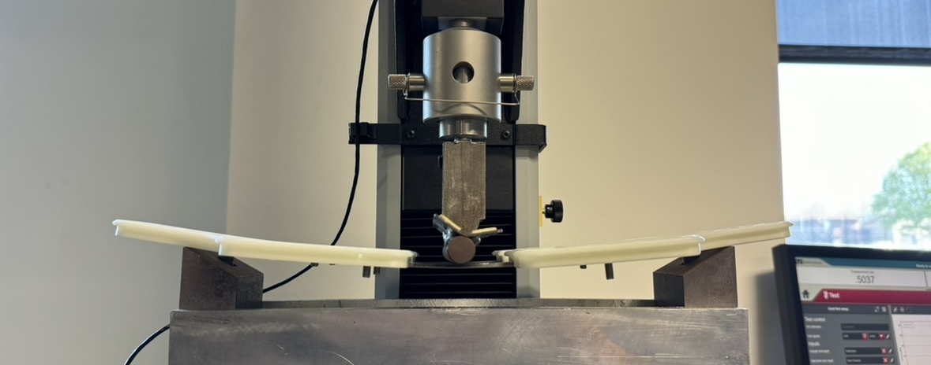
Figures 12.7

Appendix G3.1 – Procedure Checklist

Appendix G3.2 – Data Forms
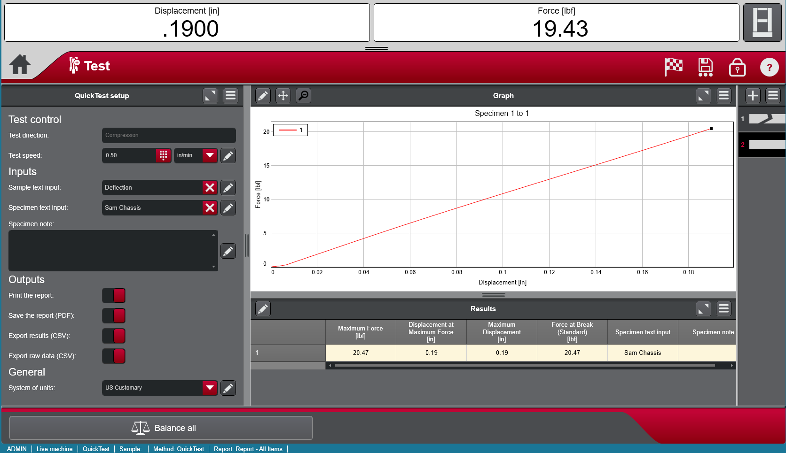
Figure 12.8

Appendix G3.3 – Raw Data
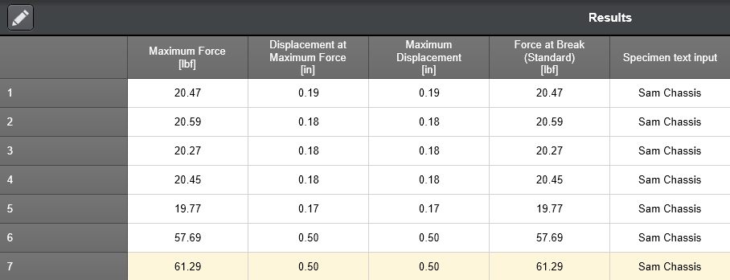
Figure 12.9

Appendix G3.4 – Evaluation Sheet

Appendix G3.5 – Schedule (Testing)

Appendix H – Resume

Sam Wang
Bellevue, WA 98005 | (425)-XXX-XXXX | Sammul.m.wang@gmail.com
Objective
As a current student at Central Washington University, I am studying mechanical engineering technology (MET) and am interested in pursuing a career that improve society through efficient infrastructure design while expanding my engineering knowledge. My academic pursuits and curiosity drive my desire to delve deeper into these fields, exploring innovative solutions and contributing to impactful projects. My work ethic coupled with my strong organizational and problem-solving skills would allow me to be a quick study and an asset to the team and a willingness to take on extra responsibilities to meet team goals. One of my greatest strengths is integrating myself to help teams function highly and effectively to drive projects to completion.

Experience
Project Engineer Intern – ProAmpac (Auburn)
06/2023 – 09/2023
- Managed material purchases regarding budget, lead time, and structural requirements.
- Created and audited AutoCAD drawings with Sr. Engineer
- Managed scheduling of external contractors and internal workload with assistance from Maintenance manager and supervisor
- Worked with machinist to review drawings for internal parts fabrication and provided feedback and guidance to ensure use of best practice, accuracy, and required details
- Worked with maintenance technicians to develop preventative maintenance plan, frequency, and instructions for calibration of press deck and mandrel
- Implemented new air circulation pattern for improved cooling of air compressors
- Utilize Fluke Acoustic imager to identify and tag compressed air leaks throughout buildings 1 & 2 then determined potential cost saving using air leak size and developed repair plan based on value and complexity of solution
Technical Engineer (US Army MOS-12T) – 659 Engineering Construction Company
09/2015 – 08/2021 – Deployments to Afghanistan and Poland
- Gathered, organized, and modeled data for reports and presentations
- Read and used topographical data to complete analysis of land plots and roadways
- Used Trimble total station and AutoCAD/Civil 3D to create detailed maps from raw field data
- Prepared blueprints and schematics for creative interior design layouts in-line with client desire and space utilization practice
- Advised contractors and engineers on ideal structure placement given drainage patterns, hydrology, site constraints, and topographical factors
- Monitored project progress, identified risks, and took corrective action as needed
- Oversaw more than 20 projects with a consistent record of meeting budget and schedule targets
Helper Clerk/Assistant Dairy Manager – Quality Food Center
08/2015 – 06/2016
- Placed supply orders, restocked supplies, and merchandised products for the dairy, juice, egg, and butter section of the department
- Rotated grocery products ensuring that expired or spoiled items were immediately removed and adhered to the “first in, first out” rule
- Assisted customers by finding items quickly to boost store satisfaction rates
- Used pallet jacks and hand trucks to move merchandise to the sales floor for restocking
- Learned duties for various positions and provided backup at all departments of the store
Education
Mechanical Engineering Technology (MET) – Graduate June 2024
Central Washington University – Ellensburg, WA
Army Individual Training - 02/2017
Brown Hall - Fort Leonard Wood, MO
High School Diploma - 06/2016
Sammamish High School – Bellevue, WA
Skills
- Computer-aided Design – Autodesk AutoCAD, Inventor, Fusion 360, Civil 3D, Terramodel, and SolidWorks
- Field Surveying – Trimble 5600, S7, R8 GPS, Auto level, Stick and Strings
- Leadership with strong team spirit
- Mechanical/Technical Engineering
- Project Management and Quality Control
- Technologically Proficient
- Always willing to take on additional responsibilities.
Languages
Chinese (Mandarin) - Native or Bilingual Proficiency
English - Native or Bilingual Proficiency
Extracurricular
- Treasurer of the American Society of Mechanical Engineers (ASME) Club at CWU
- Member of the CWU Rocketry Club

